
College of Engineering and Physical Sciences

Department of Mechanical Engineering
School of Engineering

MSc Robotics

Advanced Project

2025-26 Session

FINAL REPORT

Surname | Khose
First Name | Kunal
ID number | 3055813
Supervisor’s name | Marco Castellani
Project Title | Primitive Shape Recognition from 3D Point Clouds  Using PointNet++ Based Deep Learning

Table of Contents
Abstract 1
1. Introduction 2
1.1 Background and Motivation 2
1.2 Problem Statement 2
1.3 Aim and Objectives 2
1.4 Scope and Limitations 3
2. Literature Review and Technical Background 3
2.1 3D Point Clouds and Primitive Shape Recognition 3
2.2 Deep Learning for 3D Point Clouds 3
2.3 PointNet and PointNet++ Architectures 4
2.4 Synthetic-to-Real Generalisation in Point-Cloud Recognition 4
2.5 Datasets for 3D Object Recognition: APS, YCB-28 and ModelNet40 4
2.6 Optimisation Algorithms: AdamW and RProp 5
2.7 Summary of Research Gap 5
3. Methodology 6
3.1 Overall Experimental Workflow 6
3.2 APS Dataset Preparation: Clean, Error and Mixed Sets 6
3.3 YCB-28 Real-Object Test Set 7
3.4 ModelNet40 Primitive-Like Subset 7
3.5 Point-Cloud Preprocessing and Normalisation 7
3.6 PointNet++ Classifier Implementation 8
3.7 AdamW Training Protocol 8
3.8 RProp Optimiser Comparison Protocol 9
3.9 Evaluation Metrics and Statistical Tests 10
4. Results 10
4.1 APS Test Results 10
4.2 Original XYZ+Normals versus XYZ-Only Comparison 11
4.3 YCB-28 Main AdamW Results 12
4.4 YCB-28 Class-Wise and Object-Wise Findings 12
4.5 Statistical Comparison of Clean, Error and Mixed Training 13
4.6 ModelNet40 Primitive-Like Subset Results 14
4.7 RProp Optimiser Comparison 15
4.8 Summary of Final Results 16

5. Discussion 16
5.1 Comparison with Zheng and Castellani’s PointNet Results 16
5.2 Why XYZ-Only Input Improved Transfer 17
5.3 Why Mixed Training Was Best 17
5.4 ModelNet40 Subset Interpretation and Limitations 18
5.5 Why RProp Underperformed AdamW 18
5.6 Limitations to Validity 19
6. Impact Statement 19
6.1 Industrial and Robotics Relevance 19
6.2 Environmental and Societal Impact 19
6.3 Stakeholders and Implementation Considerations 20
7. Conclusions and Future Work 20
7.1 Main Conclusions 20
7.2 Future Work 20
References 21
Appendices 23

List of Figures
Figure 1: Overall experimental workflow. 6
Figure 2: PointNet++ architecture implemented in the final XYZ-only classifier. 8
Figure 3: Mean YCB-28 accuracy for XYZ-plus-normal and the final XYZ-only representation. 11
Figure 4: Distribution of YCB-28 accuracy for three final XYZ-only AdamW training conditions. 12
Figure 5: YCB-28 confusion matrix for the final mixed XYZ-only AdamW model across nine runs. 13
Figure 6: ModelNet40 primitive-like subset mean accuracy. 15
Figure 7: YCB-28 repeated-run accuracy for final mixed AdamW model and mixed RProp model. 15

List of Tables
Table 1: Dataset roles and sample counts used in the project. 6
Table 2: Final training settings for the AdamW and RProp experiments. 8
Table 3: XYZ-only PointNet++ accuracy (%) on APS-style test sets across nine AdamW runs. 10
Table 4: YCB-28 five-number summary and descriptive statistics across repeated runs. 11
Table 5: Final mixed-model YCB-28 class-wise accuracy & principal object-level failure cases. 13
Table 6: Pairwise Mann-Whitney U tests for YCB-28 XYZ-only AdamW runs. Kruskal–Wallis. 13
Table 7: ModelNet40 primitive-like subset mapping. Bowl-weak proxy rather than true sphere. 14
Table 8: ModelNet40 primitive-like subset results. Not full 40-class benchmark results. 14
Table 9: AdamW versus RProp on the mixed APS condition, tested on YCB-28. 15
Table 10: Contextual comparison with the reference PointNet study. 16

Abstract
Primitive-shape recognition can provide compact geometric information for robotic manipulation and remanufacturing, but collecting large labelled sets of real 3D scans is expensive. This project investigated whether a PointNet++ classifier trained on artificial primitive-shape (APS) point clouds could generalise to real-object and external CAD data. Three classes - box, cylinder and sphere were considered. The final model used 1000 XYZ coordinates per sample, hierarchical PointNet++ set-abstraction layers, AdamW optimisation and mixed APS-clean plus APS-error training. Across nine independent runs, the mixed XYZ-only model achieved 89.19% mean accuracy on the 560-sample YCB-28 test set, compared with 67.18% for the earlier mixed PointNet++ model using XYZ plus surface normals. Class-wise YCB-28 accuracies were 88.70% for boxes, 87.36% for cylinders and 90.91% for spheres. On a 486-sample primitive-like subset of ModelNet40, the mixed model achieved 81.00% mean accuracy with ten-vote test-time evaluation. Pairwise Mann–Whitney U tests confirmed significant differences between the clean, error and mixed XYZ-only YCB conditions. A supplementary RProp experiment reached 71.20% mean YCB-28 accuracy and therefore did not replace AdamW. The results show that input representation and exposure to modified synthetic geometry were important for synthetic-to-real transfer, while also identifying limitations caused by imperfect primitive mappings in external datasets.
Keywords: point clouds, PointNet++, primitive shape recognition, synthetic-to-real generalisation, YCB.

1. Introduction

1.1 Background and Motivation
Three-dimensional point clouds are increasingly used in robotics because they preserve geometric information that can be lost in two-dimensional imagery. For manipulation, disassembly and remanufacturing, a complete semantic identity is not always necessary: an approximate primitive description such as box, cylinder or sphere can already constrain grasp selection, pose reasoning and task planning. Zheng and Castellani demonstrated this concept by training the original PointNet architecture on computer-generated primitives and testing it on real YCB objects [9]. Their work was motivated by automated remanufacturing, where appearance and condition vary and geometric cues may transfer better than texture. Related mechanical-part recognition work further supports the relevance of point-cloud learning to robotic disassembly [12].
This project retains that APS-to-YCB synthetic-to-real logic but replaces PointNet with PointNet++, which learns hierarchical local geometry [2]. It also evaluates input representation, clean/error/mixed APS training, an external ModelNet40 primitive-like subset, repeated-run statistics and a supplementary RProp comparison. The central question is therefore not only whether synthetic primitives can be classified, but whether the learned geometry transfers consistently to less ideal objects.

1.2 Problem Statement
Point clouds are unordered, irregular and non-grid data. Their density can vary locally, and real objects often deviate from ideal geometric primitives through handles, tapering, rounded edges, cavities or compound structures. A classifier trained only on mathematically clean synthetic shapes can therefore achieve high in-domain accuracy while still failing on realistic objects. This synthetic-to-real gap is particularly important when synthetic training is used to avoid the cost of collecting and labelling large real datasets. The central problem in this project was consequently not simply to maximise APS test accuracy, but to obtain a reproducible three-class PointNet++ model that retained strong performance when evaluated on independent object sets with different geometry and data provenance.

1.3 Aim and Objectives
The aim was to evaluate PointNet++-based primitive-shape recognition from 3D point clouds, with particular emphasis on generalisation from artificial training data to real-object geometry. The objectives were to: (i) implement a three-class PointNet++ classifier for box, cylinder and sphere recognition, (ii) prepare APS clean, error and mixed training conditions and controlled validation/test sets, (iii) compare XYZ-plus-normal and XYZ-only inputs, (iv) test the trained models on YCB-28 without using YCB data for training or model selection, (v) evaluate generalisation on a primitive-like subset of ModelNet40, (vi) compare AdamW with RProp as an alternative gradient-based learning algorithm, and (vii) quantify variability using repeated runs, descriptive statistics and non-parametric significance tests.

1.4 Scope and Limitations
The study is deliberately limited to three primitive classes and does not claim a universal object-recognition system. YCB-28 is the primary real-object evaluation, while ModelNet40 is used only through a manually defined primitive-like subset because the trained classifier has three outputs rather than forty. The ModelNet40 sphere mapping is especially weak because the dataset has no true ball or sphere category, bowl is used only as a curved proxy. The APS validation and test sets used in the final pipeline are balanced APS-style sets generated separately from the original 591-sample training data, rather than an official benchmark split. Finally, the RProp comparison was restricted to the mixed APS condition after that condition had already proved strongest with AdamW. These design choices are reported explicitly so that the numerical results are interpreted as controlled experimental evidence rather than leaderboard benchmark scores.

2. Literature Review and Technical Background

2.1 3D Point Clouds and Primitive Shape Recognition
A point cloud represents a surface as an unordered set of spatial samples, commonly XYZ coordinates and sometimes additional attributes such as color or normals. Unlike pixels or voxels, points have no fixed neighborhood topology, permutation invariance and local geometric reasoning must therefore be handled explicitly by the learning method [1-3].
Primitive recognition reduces complex object geometry to a small vocabulary such as boxes, cylinders and spheres. This abstraction is useful when downstream manipulation depends more on gross shape than semantic identity. Baronti et al. used geometric fitting to recover primitive shapes from point clouds [11], while Zheng and Castellani showed that a learned classifier could recognise primitive-like real objects after training on artificial examples [9]. The present work follows the latter classification formulation and uses the primitive label as a compact geometric descriptor rather than a complete object model.

2.2 Deep Learning for 3D Point Clouds
Graph-based and attention-based methods such as DGCNN [4] and Point Transformer [7] can learn detailed relationships between neighbouring points, but they are more complex than required for this project. PointCNN [5] and SO-Net [6] provide other ways of learning local point-cloud structure, but they move further from the PointNet-based framework used in the reference study. PointNet++ was selected because it learns local geometric features at different scales through its hierarchical structure [2], while still being closely related to the original PointNet model used in the earlier APS-to-YCB study by Zheng and Castellani [9]. This made PointNet++ a suitable choice for extending the previous work without changing too many parts of the approach at the same time. It also allowed the effects of input representation and clean, error and mixed APS training to be studied more clearly.
PointNeXt has shown that PointNet++-based models can achieve stronger performance through improved training and model scaling [8], but introducing these additional changes here would have made it harder to determine whether improvements were caused by the network architecture or by the training strategy.

2.3 PointNet and PointNet++ Architectures
PointNet was the first widely adopted architecture to operate directly on unordered point sets [1]. It applies shared multilayer perceptron to individual points and aggregates the resulting features with a symmetric function, allowing the network output to be invariant to input ordering. This global aggregation is effective for classification but does not explicitly model fine local neighborhoods. PointNet++ addresses that limitation by recursively sampling points, grouping local neighbours and applying PointNet-style feature extraction at increasingly larger spatial scales [2].
The hierarchical principle is appropriate for primitive recognition because features such as planar patches, local curvature and elongated cylindrical structure are fundamentally local before they contribute to a global object description. In the implementation used here, two local set-abstraction stages were followed by a global abstraction stage and fully connected classification layers. The final network used only XYZ coordinates. This differs from the original Zheng and Castellani study, which used the original PointNet rather than PointNet++ [9]. The present work should therefore be viewed as an extension of the APS-to-YCB experimental concept, not as an exact replication.

2.4 Synthetic-to-Real Generalisation in Point-Cloud Recognition
Training on synthetic geometry reduces the cost of collecting labelled real scans, but it creates a domain gap. Artificial primitives have regular surfaces and controlled sampling, whereas real objects can be incomplete, rounded, compound, noisy or only approximately primitive.
Zheng and Castellani observed the same issue directly: PointNet trained on APS-clean achieved a median 78.84% on YCB-28, while training with error-corrupted APS raised the median to 85.98% [9]. This suggests that controlled perturbation can expose a classifier to deviations that better resemble real geometry. In this project, the idea is extended by comparing clean, error and mixed APS training and by testing whether XYZ-only input reduces additional cross-domain mismatch.

2.5 Datasets for 3D Object Recognition: APS, YCB-28 and ModelNet40
The APS data used in the reference work were generated from artificial box, cylinder and sphere models. The clean set contains 591 point clouds, and an error-corrupted counterpart introduces controlled coordinate perturbations [9,11]. YCB provides standardised everyday objects for manipulation research [13]. The YCB-28 protocol selects 28 objects that can be approximated by the three primitive classes and is therefore the primary real-object test in this project [9,13].
ModelNet40 originates from the ModelNet/3D ShapeNets CAD collection [14]. Because the present classifier has only three outputs, the full 40-class benchmark is not directly compatible. A manually mapped primitive-like subset is therefore used only as an additional external CAD evaluation. This distinction is important: the reported ModelNet result measures transfer on the selected subset, not performance on the official 40-class task.

2.6 Optimisation Algorithms: AdamW and RProp
Neural-network training adjusts weights using gradients of a loss function. Adam combines first-order gradient information with adaptive estimates of the first and second moments of the gradients [15]. AdamW modifies this approach by decoupling weight decay from the gradient-based loss update, providing a clearer form of parameter regularisation [16]. AdamW was used for the main PointNet++ experiments because it is well suited to stochastic mini-batch training and allowed weight decay to be applied directly.
RProp is also a backpropagation learning algorithm, but its parameter updates depend primarily on the sign of the partial derivative rather than the gradient magnitude, individual step sizes are increased or decreased according to successive gradient signs [17]. That behaviour was attractive as a substantially different optimisation mechanism for the supplementary comparison. However, classic RProp was designed around deterministic or batch gradients, so its behaviour in noisy mini-batch deep learning can differ from adaptive-moment methods. The comparison in this report therefore evaluates empirical suitability for this particular PointNet++ transfer problem rather than asserting that one optimiser is universally superior.

2.7 Summary of Research Gap
The literature establishes direct point-cloud learning, hierarchical PointNet++ features, synthetic-to-real difficulty and the value of altered APS training. A narrower gap remains at their intersection: there is limited evidence on how a PointNet++ classifier trained exclusively on APS primitives transfers to the YCB-28 abstraction used by Zheng and Castellani, particularly when input normals are removed and training is repeated under clean, error and mixed conditions. The project addresses that gap and adds two checks on the robustness of the conclusion: an external CAD subset and an alternative optimiser.

3. Methodology

3.1 Overall Experimental Workflow
Figure 1 summarises the experimental workflow. APS data were used for training and APS-style validation was used to select checkpoints. YCB-28 and ModelNet40 remained external to the training process. The first stage established a PointNet++ baseline using XYZ coordinates plus normals. The second stage retrained PointNet++ using XYZ only with a stronger training protocol. Clean, error and mixed conditions were each repeated nine times. The final mixed AdamW checkpoints were then evaluated more deeply, including class-wise and object-wise YCB analysis. ModelNet40 provided an additional external CAD check, and RProp was trained separately on the mixed APS condition for ten independent runs.

The implementation and supporting notebooks are available in the project repository.
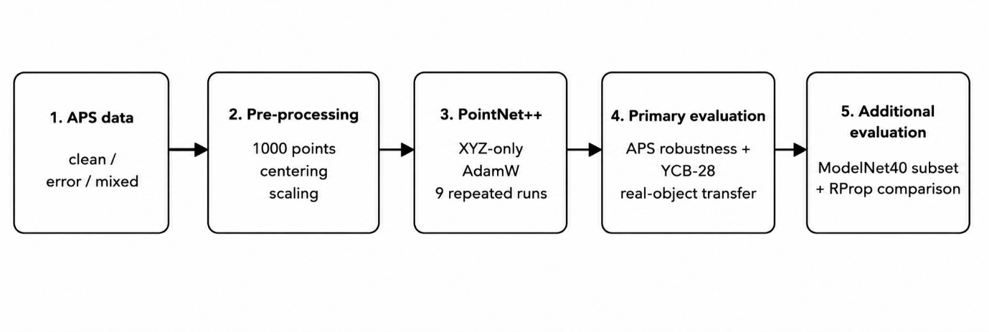
Figure 1: Overall experimental workflow. APS data are used for training and validation, YCB-28 and the ModelNet40 primitive-like subset are external evaluations.
Table 1: Dataset roles and sample counts used in the project.
Dataset | Role | Samples | Classes / mapping
APS-clean | Training | 591 | 220 box, 190 cylinder, 181 sphere
APS-error | Training | 591 | Noisy counterpart of APS-clean
APS mixed | Training | 1182 | APS-clean + APS-error
APS-style test | Test | 600 | 200 per primitive class
APS-style validation | Validation | 600 | 200 per primitive class
YCB-28 | External real-object test | 560 | 28 objects, 9 box, 8 cylinder, 11 sphere
ModelNet40 subset | External CAD test | 486 | 226 box, 240 cylinder, 20 bowl proxy

3.2 APS Dataset Preparation: Clean, Error and Mixed Sets
The APS-clean training set contained 591 samples: 220 boxes, 190 cylinders and 181 spheres. APS-error contained the same 591 shapes with point-coordinate perturbations. In the reference dataset, each point was displaced within δ ∈ [−0.05L, +0.05L], where L is the bounding-box side length, giving a 5% error level [10]. The mixed condition combined APS-clean and APS
error, giving 1182 training samples. Earlier work showed that perturbed APS shapes can improve robustness to less ideal geometry [9,10].
Separate balanced validation and test sets of 600 samples each were generated, with 200 samples per class. From the clean test set, APS-error used uniform XYZ noise in [−0.025, +0.025], while APS-error-double used [−0.050, +0.050] as a stronger robustness test. These evaluation sets were generated separately from the original training files and were not used for model training or checkpoint selection.

3.3 YCB-28 Real-Object Test Set
The YCB-28 protocol followed the object mapping used in the reference primitive-recognition study [9]. Nine objects were treated as box-like, eight as cylinder-like and eleven as sphere-like. Twenty point clouds were prepared per object, giving 560 test samples. Each sample contained 1000 points. Object meshes were sampled and normalised to the same input convention as the APS data.
YCB-28 was used only after model training and checkpoint selection. Consequently, its accuracy estimates synthetic-to-real transfer rather than performance after domain-specific fine-tuning. This distinction is central to the project: the final 89.19% result is not a training accuracy and not the outcome of optimisation on YCB labels.

3.4 ModelNet40 Primitive-Like Subset
The standard point-cloud version of ModelNet40 contains 2048 XYZ points per sample. A 486-sample primitive-like subset was selected because a three-output classifier cannot be evaluated meaningfully on all forty semantic classes. The box mapping comprised glass_box, xbox, wardrobe and night_stand (226 samples), the cylinder mapping comprised bottle, cup, vase and flower_pot (240 samples), bowl supplied twenty samples as a weak sphere-like proxy. No claim is made that this constitutes the full ModelNet40 benchmark. Each selected sample was centred, scaled by its bounding-box diagonal and resampled to 1000 points. Initial single-pass evaluation compared clean, error and mixed checkpoints.
Since each 2048-point object must be reduced to 1000 points, a ten-vote test-time procedure was subsequently applied to the final mixed condition: ten random 1000-point subsets were evaluated and the class probabilities were averaged. This changes only evaluation stability and does not retrain the model.

3.5 Point-Cloud Preprocessing and Normalisation
All final models used 1000 XYZ points per sample. In the main AdamW APS-to-YCB pipeline, the shared dataset loader centred each point cloud by subtracting its centroid and then divided the centred coordinates by the maximum Euclidean distance from the centroid:
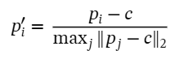
where (pᵢ) is the original coordinate vector of point i, (c) is the point-cloud centroid, and (p′ᵢ) is the normalised coordinate vector. This centres the object at the origin and scales the furthest point to unit distance. YCB-28 point-cloud files were first generated from object meshes using bounding-box-diagonal scaling and centring; before inference they were passed through the same AdamW loader, which applied above Equation. ModelNet40 and the supplementary RProp experiment used centring and bounding-box-diagonal scaling directly. Only XYZ coordinates were retained for the final classifier.

3.6 PointNet++ Classifier Implementation
The classifier was implemented in PyTorch using PointNet++ set abstraction. The final input tensor contained 1000 XYZ points with no normal channel. The first abstraction layer sampled 512 centroids (radius 0.2, 32 neighbours) and applied shared MLP widths 64-64-128. The second sampled 128 centroids (radius 0.4, 64 neighbours) with MLP 128-128-256. A global abstraction stage used MLP 256-512-1024. The resulting 1024-dimensional feature passed through fully connected layers 1024→512→256→3 with batch normalisation, ReLU activations and dropout 0.4 before three-class output.
This hierarchy follows the PointNet++ principle of progressively aggregating local neighbourhood features into a global representation [2]. The model differs from the original PointNet used by Zheng and Castellani [9], consequently, this study is an extension of their experimental logic rather than an exact reproduction.
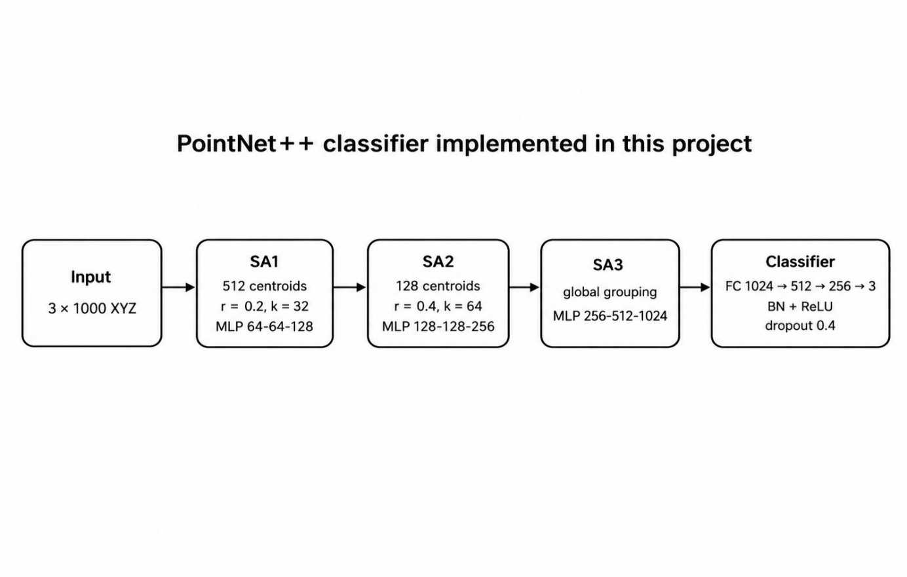
Figure 2: PointNet++ architecture implemented in the final XYZ-only classifier. SA denotes set abstraction.

3.7 AdamW Training Protocol
The final AdamW experiments used a batch size of 16, learning rate 0.0008, weight decay of 1 × 10⁻⁴, and cross-entropy loss with label smoothing 0.05. A weighted sampler and class-weighted loss were used to reduce class imbalance. Clean, error and mixed training were each repeated for nine independent runs, with a maximum of 50 epochs and early-stopping patience of 12. The best checkpoint was selected using APS validation accuracy, with validation loss used to break ties.
Training augmentation included random three-axis rotation, scaling from 0.8 to 1.2, translation from -0.02 to +0.02, Gaussian jitter with standard deviation 0.01 clipped to ±0.03, and 5% point dropout. A ReduceLROnPlateau scheduler reduced the learning rate by a factor of 0.5 after five epochs without validation-loss improvement, and gradient clipping used a maximum norm of 1.0. YCB-28 was used only for final external evaluation and not for training or checkpoint selection.
The training settings were kept the same across the clean, error and mixed conditions so that differences in performance could mainly be linked to the training data rather than changes in optimisation. The weighted sampler and class-weighted loss reduced the effect of the small APS class imbalance, while augmentation introduced geometric variation during training. Early stopping limited unnecessary training once validation performance stopped improving. Repeating each condition across nine independent runs also reduced reliance on a single random initialisation and allowed the three training conditions to be compared using repeated-run statistics.
Table 2: Final training settings for the AdamW and RProp experiments.
Setting | AdamW Main experiment | RProp comparison
Input | 1000 XYZ points | 1000 XYZ points
Training condition | Clean, error and mixed | Mixed only
Independent runs | 9 per condition | 10
Initial learning rate | 0.0008 | 0.003
Maximum epochs | 50 | 80
Weight decay | 1×10⁻⁴ | -
Label smoothing | 0.05 | 0.0
Sampling / loss balance | Weighted sampler + class-weighted loss | Class-weighted loss
Augmentation | 3-axis rotation, scale 0.8-1.2, shift ±0.02, jitter σ=0.01, clip ±0.03, 5% point dropout | Mild augmentation

3.8 RProp Optimiser Comparison Protocol
The supplementary RProp experiment retained the XYZ-only PointNet++ architecture and mixed APS training condition. Ten independent runs were trained using a batch size of 16, an initial learning rate of 0.003, a maximum of 80 epochs and early-stopping patience of 20. Mild augmentation consisted of random Z-axis rotation, scaling from 0.95 to 1.05, translation from -0.01 to +0.01 on each axis, and Gaussian jitter with standard deviation 0.002 clipped to ±0.01. No point dropout was used.
The weighted sampler and label smoothing used in the main AdamW pipeline were removed, while class-weighted cross-entropy was retained. The experiment was used as a supplementary learning-algorithm comparison rather than as a replacement for the main AdamW training study.

3.9 Evaluation Metrics and Statistical Tests
Overall classification accuracy was the primary metric. Repeated-run results are reported using mean, standard deviation, median, quartiles, minimum and maximum where appropriate. Class-wise accuracy and confusion matrices were used to identify systematic errors, while YCB object-wise accuracy was used to identify individual geometries that violated the ideal primitive abstraction.
Because neural-network learning is stochastic and the number of runs is small, pairwise Mann-Whitney U tests were used instead of assuming normality [18]. A Kruskal–Wallis test provided an omnibus comparison of the three AdamW conditions [19]. For the three pairwise tests, Holm's sequential correction controlled family-wise error [20]. Statistical significance was assessed at α=0.05. The optimiser comparison used a two-sided Mann-Whitney U test between the nine mixed AdamW accuracies and ten RProp accuracies. Statistical testing supports the repeated-run conclusions, it does not compensate for dataset-design limitations.

4. Results

4.1 APS Test Results
The final XYZ-only models retained very high accuracy on controlled APS-style data. Table 3 shows that clean training was effectively perfect on APS-clean and APS-error but deteriorated sharply on the stronger APS-error-double test, where mean accuracy fell to 67.52% with high run-to-run variation. In contrast, error and mixed training remained above 98.8% on APS-error-double while also retaining approximately 100% accuracy on clean APS. The result indicates that exposure to modified geometry, rather than clean synthetic performance alone, is necessary for robustness to stronger deviations.
Training and validation behaviour was checked across all 27 final AdamW runs. A train-validation accuracy gap above 5 percentage points was treated as a possible sign of overfitting and above 10 points as a stronger warning. No run exceeded either threshold. Validation accuracy was sometimes slightly higher than training accuracy because augmentation was applied only during training. Overall, the curves remained stable with no clear evidence of overfitting within the APS experiments.
Table 3: XYZ-only PointNet++ accuracy (%) on APS-style test sets across nine AdamW runs.
Training condition | APS-clean mean ± SD | APS-error mean ± SD | APS-error-double mean ± SD
Clean | 100.00 ± 0.00 | 99.83 ± 0.12 | 67.52 ± 12.49
Error | 99.96 ± 0.07 | 99.91 ± 0.12 | 98.87 ± 0.91
Mixed | 99.98 ± 0.06 | 99.93 ± 0.17 | 98.89 ± 0.83

4.2 Original XYZ+Normals versus XYZ-Only Comparison
The first PointNet++ evaluation used XYZ coordinates plus surface normals. Although APS performance was high, YCB-28 transfer was weak: mean accuracies for clean, error and mixed training were 66.05%, 67.32% and 67.18%. The model was then retrained using XYZ only while retaining APS-only training. Mean YCB accuracies increased to 83.06%, 86.55% and 89.19%, respectively. For the mixed condition this is an improvement of approximately 22 percentage points.
The result identifies input representation as a major experimental factor. Normals were not retained simply because they add information, instead, the final representation was selected on the basis of external-transfer behaviour. The XYZ-only mixed condition also had a relatively small standard deviation of 1.90 percentage points across nine runs.
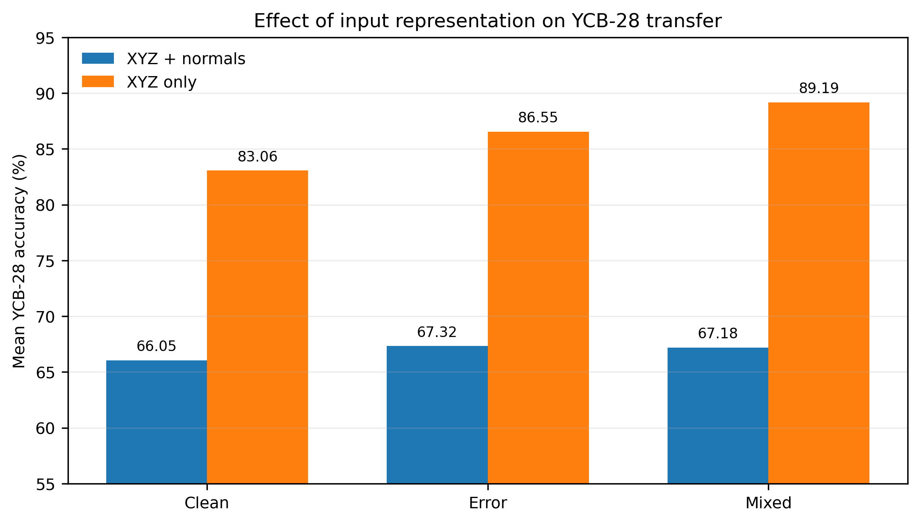
Figure 3: Mean YCB-28 accuracy for XYZ-plus-normal representation and the final XYZ-only representation.

Table 4: YCB-28 five-number summary and descriptive statistics across repeated runs (%).
Input | Training | Min | Q1 | Median | Q3 | Max | Mean | SD
XYZ+N | Clean | 61.96 | 64.11 | 64.46 | 65.54 | 75.00 | 66.05 | 4.19
XYZ+N | Error | 58.39 | 64.29 | 67.14 | 70.18 | 73.39 | 67.32 | 4.58
XYZ+N | Mixed | 63.39 | 65.00 | 68.96 | 69.82 | 72.14 | 67.18 | 3.15
XYZ | Clean | 80.71 | 81.61 | 82.68 | 84.46 | 86.07 | 83.06 | 1.90
XYZ | Error | 83.04 | 84.82 | 86.61 | 87.14 | 90.36 | 86.55 | 2.41
XYZ | Mixed | 85.71 | 87.68 | 90.00 | 90.54 | 91.25 | 89.19 | 1.90

4.3 YCB-28 Main AdamW Results
Table 4 presents the full five-number summary of YCB accuracy across the nine XYZ-only runs. Clean training achieved 83.06±1.90% mean accuracy, error training 86.55±2.41%, and mixed training 89.19±1.90%. The mixed condition also had a 90.00% median and a best run of 91.25%, with all runs between 85.71% and 91.25%. Figure 4 shows that its distribution is shifted upward relative to the clean and error conditions rather than being driven by a single exceptional run. Mixed training therefore provided the best balance of ideal and noisy synthetic examples. It was selected as final model condition and is the basis of subsequent class-wise and confusion-matrix analysis.
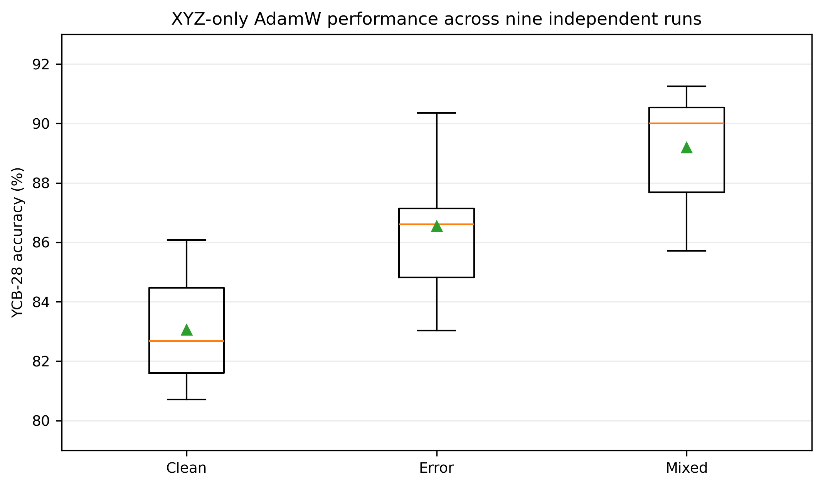
Figure 4: Distribution of YCB-28 accuracy for the three final XYZ-only AdamW training conditions.

4.4 YCB-28 Class-Wise and Object-Wise Findings
The final mixed model was balanced across the three primitive classes: box 88.70%, cylinder 87.36% and sphere 90.91%. The aggregated confusion matrix shows that most residual errors were between boxes and cylinders, while spheres were the most reliable class. Across nine runs, 1,800 of 1,980 sphere predictions were correct.
At object level, 25 of 28 YCB objects were majority-correct and 14 achieved 100% accuracy across the aggregated predictions. The three weakest objects were 063_a_marbles (0%), 040_large_marker (32.22%) and 026_sponge (35%). These are boundary cases for the primitive abstraction: the marbles form a compound cluster rather than one sphere, the marker is an unusually thin cylinder, and the sponge is a rounded irregular cuboid. Their errors therefore indicate limits of the three-class geometric mapping rather than a uniform collapse on one primitive class.
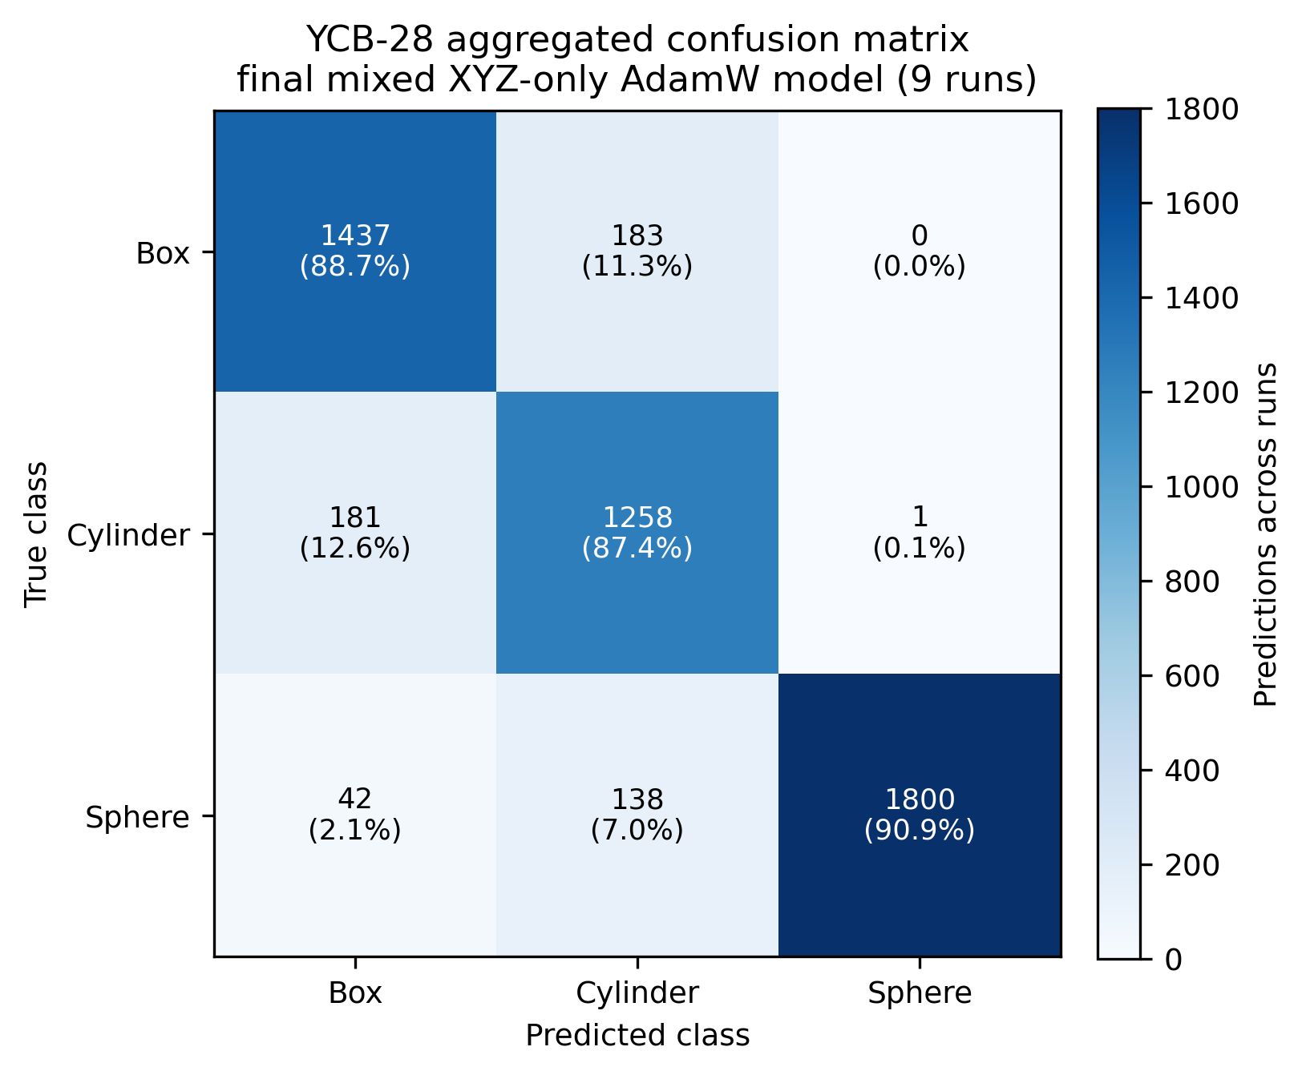
Figure 5: Aggregated YCB-28 confusion matrix for the final mixed XYZ-only AdamW model across nine runs. Percentages are normalised by true class.

Table 5: Final mixed-model YCB-28 class-wise accuracy and principal object-level failure cases.
Class / item | Accuracy / result | Interpretation
Box class | 88.70% | Strong transfer, remaining errors mainly box→cylinder
Cylinder class | 87.36% | Strong but most ambiguous primitive group
Sphere class | 90.91% | Highest class-wise accuracy
063_a_marbles | 0.00% | Compound cluster, not a single sphere
040_large_marker | 32.22% | Very thin elongated cylinder
026_sponge | 35.00% | Irregular rounded cuboid

4.5 Statistical Comparison of Clean, Error and Mixed Training
The Kruskal–Wallis test found a significant overall difference among the three XYZ-only AdamW conditions (H=16.6427, p=0.000243). Pairwise Mann–Whitney tests remained significant after Holm correction: clean versus error U=9.0, adjusted p=0.0123, clean versus mixed U=1.0, adjusted p=0.00172, and error versus mixed U=14.0, adjusted p=0.0213. Thus, the ordering visible in the descriptive statistics is supported statistically across the repeated runs. In particular, the mixed condition was significantly better than both clean and error training under the chosen test procedure.

Table 6: Pairwise Mann-Whitney U tests for YCB-28 XYZ-only AdamW runs. Kruskal-Wallis: H=16.6427, p=0.000243.
Comparison | U | Raw p | Holm-adjusted p | Significant (0.05)
Clean vs Error | 9.0 | 0.006167 | 0.012334 | Yes
Clean vs Mixed | 1.0 | 0.000574 | 0.001721 | Yes
Error vs Mixed | 14.0 | 0.021346 | 0.021346 | Yes

4.6 ModelNet40 Primitive-Like Subset Results
The ModelNet40 evaluation used 486 samples from nine manually selected categories: 226 box-like, 240 cylinder-like and 20 bowl samples used as a weak sphere proxy. In single-pass testing, the clean, error and mixed models achieved mean accuracies of 71.58%, 72.57% and 79.81%, respectively. The overall difference was significant (Kruskal-Wallis H=10.0669, p=0.0065). Holm-adjusted Mann–Whitney tests showed that mixed training performed significantly better than clean (p=0.0078) and error (0.0424) training, while clean and error were not significantly different (p=0.7908).
Mixed training was therefore selected for the ten-vote evaluation. This increased the mean accuracy to 81.00% and the best result to 84.98%. Box-like accuracy was 96.07% and cylinder-like accuracy was 73.56%. The bowl proxy scored 0% because ModelNet40 has no true sphere or ball category. Therefore, these results represent only the selected primitive-like subset, not the full ModelNet40 benchmark.
Table 7: ModelNet40 primitive-like subset mapping. Bowl is a weak proxy rather than a true sphere.
Mapped primitive | ModelNet40 categories | Samples
Box-like | glass_box, xbox, wardrobe, night_stand | 226
Cylinder-like | bottle, cup, vase, flower_pot | 240
Sphere-like proxy | bowl | 20

Table 8: ModelNet40 primitive-like subset results. These are not full 40-class benchmark results.
Evaluation | Runs | Mean (%) | Median (%) | Best (%) | Main note
Clean single-pass | 9 | 71.58 | 73.87 | 76.34 | Baseline clean-trained condition
Error single-pass | 9 | 72.57 | 73.25 | 81.89 | Error trained condition
Mixed single-pass | 9 | 79.81 | 82.10 | 83.54 | Best single-pass condition
Mixed 10-vote | 9 | 81.00 | 82.30 | 84.98 | +1.19 pp mean vs single-pass

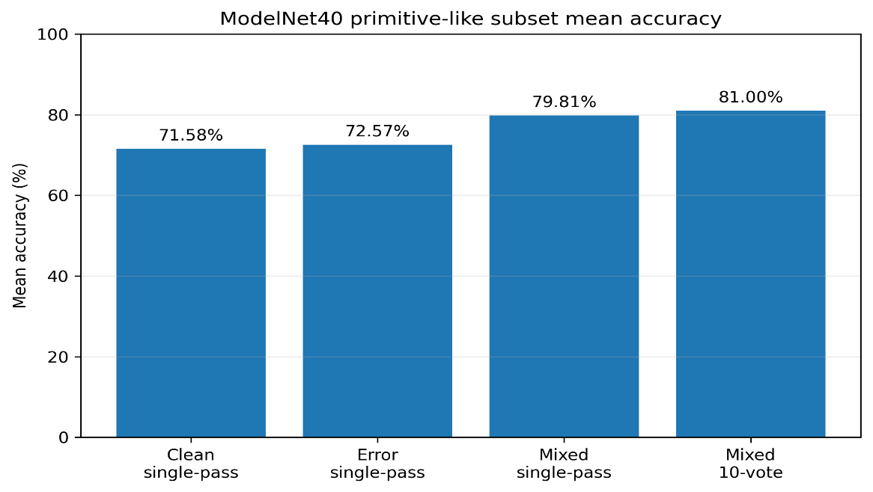
Figure 6: ModelNet40 primitive-like subset mean accuracy. Ten-vote testing was applied only after mixed training had been selected by the single-pass comparison.

4.7 RProp Optimiser Comparison
RProp trained successfully on the mixed APS condition but transferred substantially less well to YCB-28. Across ten runs, accuracy ranged from 68.75% to 72.86%, with mean 71.20%, median 71.61% and standard deviation 1.35%. The final AdamW mixed condition achieved 89.19±1.90%, a mean advantage of 17.99 percentage points. The two-sided Mann–Whitney comparison gave U=90.0 and p=0.000276, confirming a clear separation between the repeated-run distributions (Figure 7).
The RProp analysis showed that its largest weakness was the geometrically varied cylinder class. This result is useful even though it is negative: it demonstrates that changing the learning rule can materially alter synthetic-to-real generalisation while the architecture and high-level training condition remain fixed. AdamW therefore remained the final optimiser.
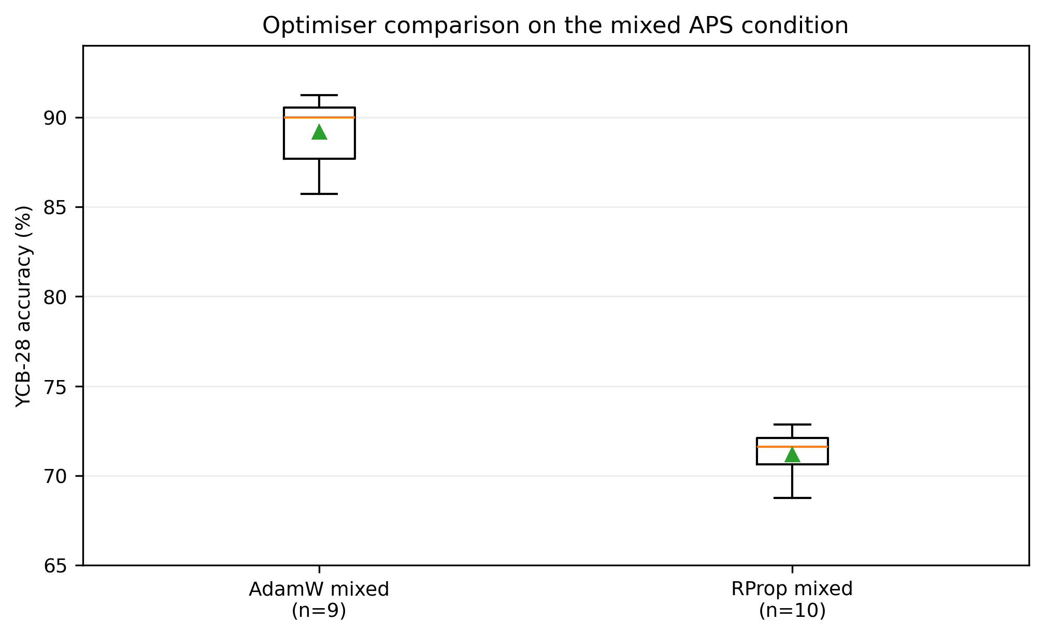
Figure 7: YCB-28 repeated-run accuracy for the final mixed AdamW model and the supplementary mixed RProp model
Table 9: AdamW versus RProp on the mixed APS condition, tested on YCB-28.
Optimiser | Runs | Mean (%) | Median (%) | Best (%) | SD (%) | Mann–Whitney result
AdamW | 9 | 89.19 | 90.00 | 91.25 | 1.90 | U=90.0, p=0.000276
RProp | 10 | 71.20 | 71.61 | 72.86 | 1.35 | AdamW > RProp

4.8 Summary of Final Results
The experiments identify one consistent final configuration: mixed APS-clean plus APS-error training, XYZ-only PointNet++, and AdamW optimisation. It retained approximately 99% robustness on the controlled clean/error APS tests, achieved 89.19% mean accuracy on the independent YCB-28 real-object set, and produced the highest performance among the three training conditions on the ModelNet40 primitive-like subset. The RProp experiment did not challenge that conclusion.

5. Discussion

5.1 Comparison with Zheng and Castellani’s PointNet Results
The closest published comparison is Zheng and Castellani's APS-to-YCB study using original PointNet [9]. Across ten learning trials, their reported YCB-28 median accuracies were 78.84% for APS-clean, 85.98% for APS-error and 80.71% for YCB-similar training. Their later optimiser study reported further PointNet experiments with Adam and CEST. Optimised CEST reached median YCB accuracies of 89.20% on APS-error and 88.21% on APS-all [10].
The present mixed XYZ-only PointNet++ model achieved a 90.00% median and 89.19% mean YCB accuracy. These values show that the proposed pipeline is competitive with the strongest published APS-to-YCB results, but they are not a controlled architecture-only comparison: PointNet++ architecture, optimiser, augmentation, training composition and preprocessing all differ. The defensible conclusion is therefore that PointNet++ successfully extends the APS-to-YCB workflow and that the selected representation and mixed training produced strong transfer, not that PointNet++ alone is proven superior to PointNet or CEST.
Table 10: Contextual comparison with the reference PointNet study. Values are not a controlled architecture-only benchmark because training procedures differ.
Study / model | Training condition | YCB-28 statistic | Accuracy (%)
Zheng and Castellani PointNet [9] | APS-clean | Median (10 runs) | 78.84
Zheng and Castellani PointNet [9] | APS-error | Median (10 runs) | 85.98
Zheng and Castellani PointNet [9] | YCB-similar | Median (10 runs) | 80.71
This study PointNet++ | APS-clean, XYZ-only | Median (9 runs) | 82.68
This study PointNet++ | APS-error, XYZ-only | Median (9 runs) | 86.61
This study PointNet++ | Mixed, XYZ-only | Median (9 runs) | 90.00

5.2 Why XYZ-Only Input Improved Transfer
The input comparison suggests that the earlier model had learned features that were highly predictive inside the synthetic APS domain but unstable across data sources. Normal vectors encode local surface orientation and are theoretically useful for separating flat boxes from curved cylinders and spheres. Their quality, however, depends on mesh construction, sampling density and normal-estimation convention. If those characteristics differ between APS and YCB, normals can become a shortcut feature tied to the source domain. Removing them leaves only coordinate geometry, and PointNet++ is specifically designed to recover local structure from spatial neighbourhoods.
This explanation is consistent with the 22-point mixed-condition improvement but should remain a hypothesis because the experiment did not systematically vary normal-estimation algorithms. A useful future ablation would compute normals for all datasets using exactly the same estimator and neighbourhood size, then compare them with XYZ-only under otherwise identical training.

5.3 Why Mixed Training Was Best
Clean APS teaches crisp class prototypes but under-represents deviations from ideal geometry. Error-corrupted APS expands the local distribution around those prototypes. The mixed dataset exposes the classifier to both, which helps preserve the canonical shape while broadening the learnt decision region. This interpretation is supported by both external tests. On APS-error-double, clean training fell to 67.52% whereas mixed training remained at 98.89%. On YCB-28, the clean, error and mixed means increased from 83.06% to 86.55% and 89.19%, respectively. The significant pairwise tests indicate that this progression is larger than the observed run-to-run variability.
The result also aligns qualitatively with Zheng and Castellani's finding that error-corrupted APS improved PointNet transfer [9]. The present study extends that observation by showing that combining clean and error examples was stronger than either condition alone for the final PointNet++ pipeline.

5.4 ModelNet40 Subset Interpretation and Limitations
ModelNet40 is useful because its CAD objects constitute a different external source from both APS and YCB. Strong box accuracy and moderate cylinder accuracy therefore provide additional evidence that the mixed model learned transferable shape cues. Nevertheless, the subset is curated and its classes were manually mapped. It must not be described as an 81% result on the full ModelNet40 benchmark.
The bowl failure illustrates why semantic categories and primitive classes cannot be equated automatically. A bowl contains substantial curved surface area, but its opening and concavity make its global topology closer to a hollow cylindrical shell than to a closed sphere. The absence of true sphere categories means ModelNet40 provides essentially no fair test of the sphere output. YCB-28, which contains balls and fruit-like objects, remains the appropriate sphere evaluation in this project.
For this reason, YCB-28 remains the stronger external test of the final model. Its objects are real everyday items with handles, rounded edges, different proportions and other departures from ideal primitives, while still providing examples that can reasonably be mapped to all three target classes. ModelNet40 serves a different purpose: it checks whether the learned features also transfer to a separate CAD dataset with different object categories and sampling. Agreement between the two evaluations strengthens the evidence for box and cylinder transfer, but the ModelNet40 result should not be given the same weight as YCB-28 when judging overall three-class performance.

5.5 Why RProp Underperformed AdamW
AdamW uses gradient magnitude through adaptive moment estimates and operates naturally with noisy mini-batch gradients [15,16]. RProp adapts per-parameter step sizes principally from changes in gradient sign [17]. In the present deep point-cloud setting, random augmentation, mini-batch sampling and varied geometry can cause sign fluctuations that are not necessarily evidence that a parameter has crossed a stable optimum. This may reduce the usefulness of the classical RProp update logic.
The empirical pattern supports a transfer rather than a total training failure: RProp reached reasonable APS validation performance, yet YCB accuracy remained near 71%. Its weak cylinder behaviour is plausible because YCB cylinders include cans, cups, a mug, a marker and pitcher-like geometry rather than one uniform primitive. AdamW's adaptive stochastic updates appear better suited to the selected training pipeline, although the result is configuration-specific and does not establish a general theoretical dominance over RProp. Because the RProp experiment also used different augmentation and class-balancing settings, the observed difference cannot be attributed to the optimiser alone and should be interpreted as a comparison between the two final training configurations.

5.6 Limitations to Validity
Several limitations constrain generalisation. Only three primitive classes were considered, and APS is a relatively small synthetic dataset. YCB-28 contains repeated samples from 28 object identities, so high sample accuracy does not guarantee equivalent performance on arbitrary unseen object families. The ModelNet40 subset is manually curated and its bowl mapping is not a valid sphere benchmark. Hyperparameter exploration was practical rather than exhaustive, and RProp was evaluated only for mixed training. Finally, no sensor-native or end-to-end robot experiment was conducted. The reported results therefore establish classification behaviour under the defined protocols, while the proposed benefits for grasping and disassembly remain to be validated at task level.

6. Impact Statement

6.1 Industrial and Robotics Relevance
Primitive-shape recognition could support robotic perception in disassembly, remanufacturing and automated handling. Identifying an object as box-like, cylindrical or spherical can help narrow possible grasp positions, end-effector orientation and handling strategies. Training mainly on synthetic APS data may also reduce the time and cost of collecting and labelling large real 3D datasets. For manufacturers and robotic-system integrators, this could provide a lower-cost way to develop and test perception models before larger real-world trials. However, this project does not demonstrate direct production or cost savings.
A practical advantage of the approach is that the three-class output is simple and could be used as an early filtering stage rather than replacing a complete object-recognition system. For example, a robot could first estimate whether a component is mainly box-like, cylindrical or spherical and then apply a more specialised pose or grasp method. This may reduce the search space for later processing. However, any commercial benefit would depend on the cost of 3D sensing, computing hardware, system integration and the level of accuracy required for the intended manufacturing task.

6.2 Environmental and Societal Impact
Improved robotic disassembly and remanufacturing could support the reuse, repair and recovery of components that might otherwise be discarded. More reliable geometric recognition may help robots sort and handle parts more effectively, supporting material recovery and waste reduction. Automated perception could also reduce some repetitive manual inspection tasks. These are potential benefits rather than outcomes directly demonstrated in this project, and they must be balanced against the computing and energy required to train and run deep-learning models.

6.3 Stakeholders and Implementation Considerations
The main stakeholders include remanufacturing companies, manufacturers, robotic-system integrators, automation engineers and researchers working on 3D perception. Before deployment, the classifier would require testing on sensor-based partial point clouds, a wider range of objects and real operating conditions. Confidence thresholds and methods for handling objects outside the three primitive classes would also be needed. Misclassification could lead to an unsuitable grasp or robot motion, so the classifier should not be used as a stand-alone decision system. It should instead be combined with pose estimation, collision checking and grasp validation before industrial use.

7. Conclusions and Future Work

7.1 Main Conclusions
This project showed that PointNet++ can extend APS-based primitive recognition to independent object datasets when the training pipeline is designed for transfer rather than synthetic accuracy alone. The final model is the mixed-trained XYZ-only PointNet++ classifier optimised with AdamW. It achieved 89.19% mean YCB-28 accuracy across nine runs, with balanced box, cylinder and sphere performance and significant improvements over clean and error training. Removing normals improved the mixed YCB mean from 67.18% to 89.19%, while mixed training retained 98.89% accuracy on the strongest APS-error-double robustness test.
The ModelNet40 primitive-like subset produced 81.00% mean accuracy with ten-vote evaluation, although its sphere mapping is not valid as a true sphere benchmark. RProp achieved only 71.20% mean YCB accuracy and did not replace AdamW.
Overall, the main contribution of the project is not simply the highest classification accuracy, but the identification of a training configuration that generalised consistently beyond the synthetic APS domain. The results show that mixed synthetic training and XYZ-only input were more important to external transfer than achieving near-perfect performance on clean synthetic data alone.

7.2 Future Work
The most important next step is evaluation using sensor-native partial point clouds, including occlusion, missing regions and measurement noise, because the current external tests use prepared object models rather than direct robot-camera observations. A controlled normal-estimation study could then determine whether surface information can be reintroduced without increasing domain mismatch. Further work could also expand the primitive vocabulary and compare alternative architectures under exactly the same training and evaluation protocol. Finally, integrating the classifier with pose estimation and grasp planning would show whether improved primitive recognition produces measurable benefits in a real robotic disassembly or handling task.

References
1. Qi CR, Su H, Mo K, Guibas LJ. PointNet: Deep learning on point sets for 3D classification and segmentation. In: Proceedings of the IEEE Conference on Computer Vision and Pattern Recognition. 2017. p. 652–660.
2. Qi CR, Yi L, Su H, Guibas LJ. PointNet++: Deep hierarchical feature learning on point sets in a metric space. Advances in Neural Information Processing Systems. 2017,30:5099–5108.
3. Guo Y, Wang H, Hu Q, Liu H, Liu L, Bennamoun M. Deep learning for 3D point clouds: A survey. IEEE Trans Pattern Anal Mach Intell. 2021,43(12):4338–4364.
4. Wang Y, Sun Y, Liu Z, Sarma SE, Bronstein MM, Solomon JM. Dynamic Graph CNN for learning on point clouds. ACM Trans Graph. 2019,38(5):Article 146.
5. Li Y, Bu R, Sun M, Wu W, Di X, Chen B. PointCNN: Convolution on X-transformed points. Advances in Neural Information Processing Systems. 2018,31.
6. Li J, Chen BM, Lee GH. SO-Net: Self-organising network for point cloud analysis. In: Proceedings of the IEEE Conference on Computer Vision and Pattern Recognition. 2018. p. 9397–9406.
7. Zhao H, Jiang L, Jia J, Torr PHS, Koltun V. Point Transformer. In: Proceedings of the IEEE/CVF International Conference on Computer Vision. 2021. p. 16259–16268.
8. Qian G, Li Y, Peng H, Mai J, Hammoud HAAK, Elhoseiny M, Ghanem B. PointNeXt: Revisiting PointNet++ with improved training and scaling strategies. Advances in Neural Information Processing Systems. 2022,35:23192–23204.
9. Zheng S, Castellani M. Primitive shape recognition from real-life scenes using the PointNet deep neural network. Int J Adv Manuf Technol. 2023,124:3067–3082.
10. Zheng S, Lan F, Castellani M. A competitive learning scheme for deep neural network pattern classifier training. Appl Soft Comput. 2023,146:110662.
11. Baronti L, Alston M, Mavrakis N, Ghalamzan E, Amir M, Castellani M. Primitive shape fitting in point clouds using the Bees Algorithm. Appl Sci. 2019,9(23):5198.
12. Zheng S, Lan F, Baronti L, Pham DT, Castellani M. Automatic identification of mechanical parts for robotic disassembly using the PointNet deep neural network. Int J Manuf Res. 2022,17(1):1–21.
13. Calli B, Singh A, Walsman A, Srinivasa S, Abbeel P, Dollar AM. The YCB object and model set: Towards common benchmarks for manipulation research. In: 2015 International Conference on Advanced Robotics. IEEE, 2015. p. 510–517.
14. Wu Z, Song S, Khosla A, Yu F, Zhang L, Tang X, Xiao J. 3D ShapeNets: A deep representation for volumetric shapes. In: Proceedings of the IEEE Conference on Computer Vision and Pattern Recognition. 2015. p. 1912–1920.
15. Kingma DP, Ba J. Adam: A method for stochastic optimisation. In: International Conference on Learning Representations. 2015.
16. Loshchilov I, Hutter F. Decoupled weight decay regularisation. In: International Conference on Learning Representations. 2019.
17. Riedmiller M, Braun H. A direct adaptive method for faster backpropagation learning: The RPROP algorithm. In: Proceedings of the IEEE International Conference on Neural Networks. 1993. Vol. 1, p. 586–591.
18. Mann HB, Whitney DR. On a test of whether one of two random variables is stochastically larger than the other. Ann Math Stat. 1947,18(1):50–60.
19. Kruskal WH, Wallis WA. Use of ranks in one-criterion variance analysis. J Am Stat Assoc. 1952,47(260):583–621.
20. Holm S. A simple sequentially rejective multiple test procedure. Scand J Stat. 1979,6(2):65–70.

Appendices

Appendix A. Dataset object and category lists
The following tables summarise the YCB-28 object mapping and the ModelNet40 primitive-like category mapping used in this project.
Appendix Table A1. YCB-28 primitive-class mapping used in this project.
Primitive class | No. of objects | Objects
Box-like | 9 | cracker box, sugar box, pudding box, gelatin box, potted meat can, sponge, wood block, foam brick, rubiks cube
Cylinder-like | 8 | chips can, master chef can, tomato soup can, tuna fish can, pitcher base, mug, large marker, cups
Sphere-like | 11 | strawberry, lemon, peach, orange, plum, softball, baseball, tennis ball, racquetball, golf ball, marbles

Appendix Table A2. ModelNet40 primitive-like category mapping used in this project.
Mapped primitive | No. of categories | ModelNet40 categories
Box-like | 4 | glass_box, xbox, wardrobe, night_stand
Cylinder-like | 4 | bottle, cup, vase, flower_pot
Sphere-like proxy | 1 | bowl

Appendix B. Hyperparameter summary
Appendix Table B1 provides a compact comparison of the final AdamW configuration and the supplementary RProp comparison.

Appendix Table B1. Hyperparameter settings for the final AdamW and supplementary RProp experiments.

Setting | AdamW main experiment | RProp comparison
Architecture | PointNet++ | PointNet++
Input | XYZ only | XYZ only
Points per sample | 1000 | 1000
APS training condition | Clean, error and mixed | Mixed only
Optimiser | AdamW | RProp
Independent runs | 9 per condition | 10
Batch size | 16 | 16
Initial learning rate | 0.0008 | 0.003
Weight decay | 1 × 10⁻⁴ | -
Loss | Cross-entropy | Class-weighted cross-entropy
Label smoothing | 0.05 | 0.0
Maximum epochs | 50 | 80
Early-stopping patience | 12 | 20
Weighted sampler | Yes | No
Augmentation | Rotation, scale, jitter, shift and point dropout | Mild augmentation

Appendix C. Additional confusion-matrix details
The aggregated confusion matrix below shows the exact prediction counts for the final mixed AdamW model across nine independent runs. Rows represent true classes and columns represent predicted classes.
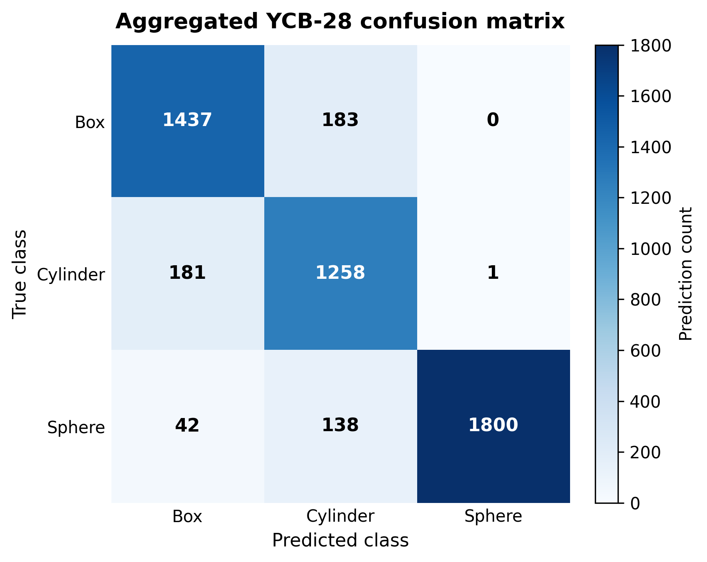
Appendix Figure C1. Aggregated YCB-28 confusion matrix for the final mixed AdamW model across nine runs.

The confusion matrix aggregates predictions across the nine independently trained mixed AdamW checkpoints. Consequently, the counts represent repeated evaluation predictions rather than unique physical objects.

Appendix D. Object-wise result notes
The three YCB-28 objects with mean object-level accuracy below 50% are summarised in Appendix Table D1. The accompanying figure provides a visual comparison of these lowest-performing cases.
Appendix Table D1. Lowest-performing YCB-28 objects for the final mixed AdamW model.
Object | Primitive class | Mean accuracy (%) | Main interpretation
marbles | Sphere-like | 0.00 | Compound group of marbles rather than a single spherical object
large marker | Cylinder-like | 32.22 | Thin and highly elongated cylindrical geometry
sponge | Box-like | 35.00 | Irregular, rounded cuboid geometry

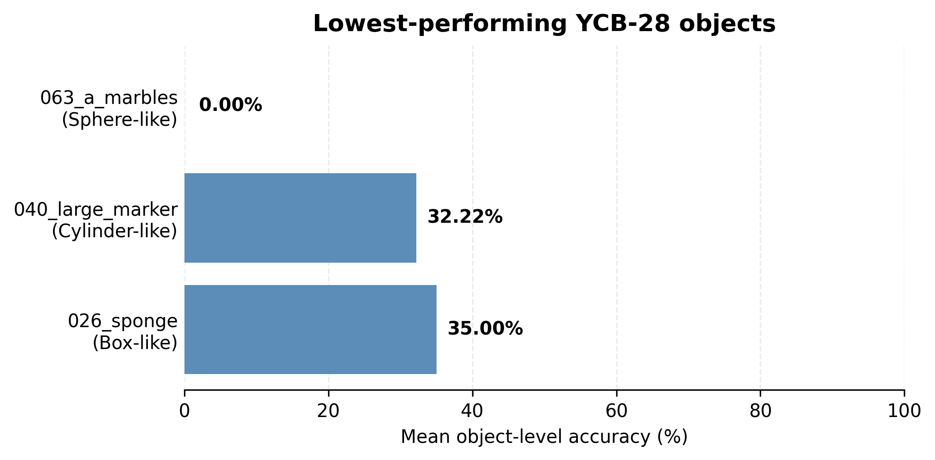
Appendix Figure D1. Mean object-level accuracy of the three lowest-performing YCB-28 objects.
Twenty-five of the 28 YCB objects were majority-correct, while 14 objects achieved 100% object-level accuracy across the aggregated repeated predictions. Full checkpoint-level prediction records are retained in the project results files.

Appendix E. Detailed statistical test outputs
Appendix Table E1. Detailed non-parametric test outputs used in the report.
Test / comparison | Statistic | Raw p | Adjusted p
Clean vs Error | 9.0 | 0.006166754 | 0.012333508
Clean vs Mixed | 1.0 | 0.000573634 | 0.001720901
Error vs Mixed | 14.0 | 0.021346320 | 0.021346320
ModelNet40 Kruskal–Wallis clean/error/mixed | H=10.0669 | 0.0065 | -
AdamW mixed vs RProp | U=90.0 | 0.000276259 | -
ModelNet clean vs error | U=37.0 | - | 0.7908
ModelNet clean vs mixed | U=6.0 | - | 0.0078
ModelNet error vs mixed | U=14.0 | - | 0.0424

Appendix F. Abbreviations and Symbols

The abbreviations and mathematical/statistical symbols used in this report are defined below.
Appendix Table F1. Technical abbreviations and notation used in this report.
Abbreviation / notation | Definition
AdamW | Adam optimiser with decoupled weight decay
APS | Artificial primitive-shape dataset
CAD | Computer-aided design
CEST | CoEvolutionary Selection Training
FC | Fully connected layer
MLP | Multilayer perceptron
pp | Percentage points
Q1 | First quartile
Q3 | Third quartile
ReLU | Rectified Linear Unit
RProp | Resilient backpropagation
SA | Set abstraction
SD | Standard deviation
XYZ | Three-dimensional Cartesian coordinates (x), (y) and (z)
XYZ+N | XYZ coordinates with surface-normal features
YCB | Yale-CMU-Berkeley object and model set
BN | Batch normalisation

Appendix Table F2. Mathematical and statistical symbols used in this report.
Symbol | Definition
pi | Original coordinate vector of point (i) in a point cloud
p_{i}’ | Normalised coordinate vector of point (i)
c | Centroid of the point cloud
d_{B} | Euclidean length of the axis-aligned bounding-box diagonal
H | Kruskal–Wallis test statistic
U | Mann–Whitney U test statistic
p | Statistical p-value
α | Statistical significance level

Appendix G. YCB-28 results
This appendix provides the run-level and object-level evidence behind the YCB-28 summaries reported in the main text. It is included for traceability and does not replace the descriptive statistics, class-wise results or aggregate confusion matrix presented in Section 4.
Appendix Table G1. Run-level YCB-28 accuracy for all final XYZ-only AdamW experiments.
Training condition | Run | Accuracy (%) | Samples
Clean | 1 | 80.89 | 560
Clean | 2 | 83.57 | 560
Clean | 3 | 82.32 | 560
Clean | 4 | 80.71 | 560
Clean | 5 | 85.18 | 560
Clean | 6 | 86.07 | 560
Clean | 7 | 84.46 | 560
Clean | 8 | 81.61 | 560
Clean | 9 | 82.68 | 560
Error | 1 | 86.61 | 560
Error | 2 | 90.00 | 560
Error | 3 | 86.61 | 560
Error | 4 | 84.64 | 560
Error | 5 | 90.36 | 560
Error | 6 | 87.14 | 560
Error | 7 | 85.71 | 560
Error | 8 | 83.04 | 560
Error | 9 | 84.82 | 560
Mixed | 1 | 91.25 | 560
Mixed | 2 | 90.54 | 560
Mixed | 3 | 87.68 | 560
Mixed | 4 | 85.71 | 560
Mixed | 5 | 90.71 | 560
Mixed | 6 | 90.36 | 560
Mixed | 7 | 90.00 | 560
Mixed | 8 | 87.14 | 560
Mixed | 9 | 89.29 | 560

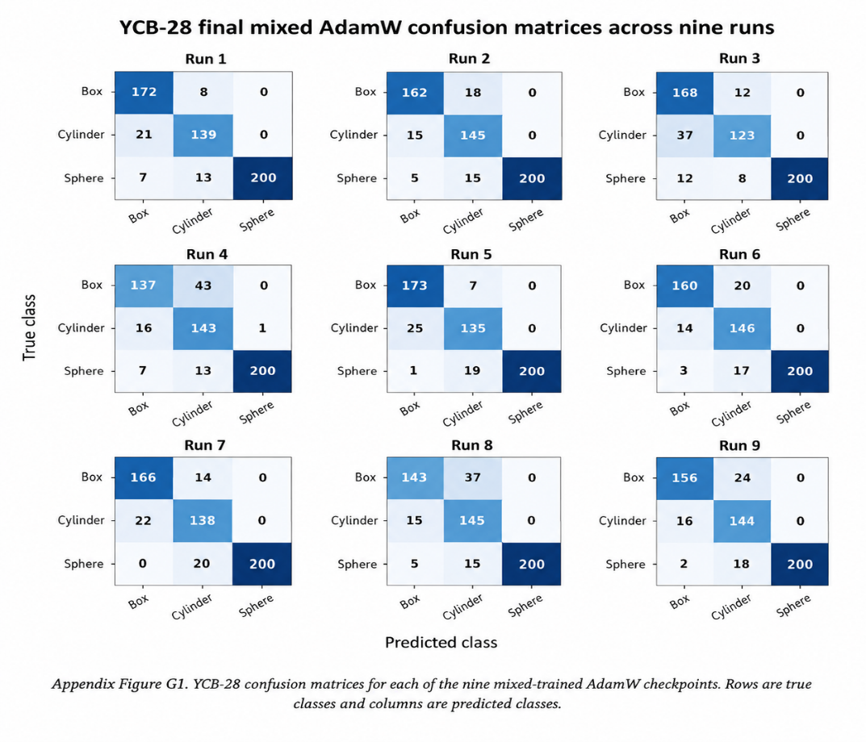
Appendix Figure G1. YCB-28 confusion matrices for each of the nine mixed-trained AdamW checkpoints. Rows are true classes and columns are predicted classes.

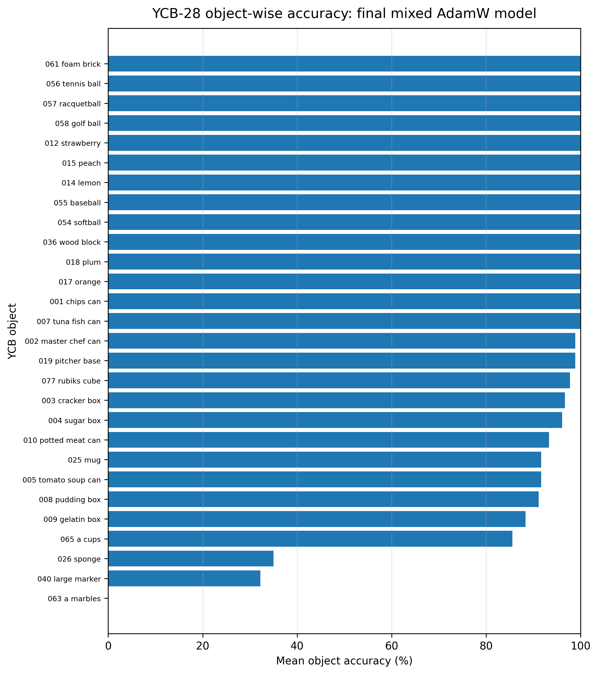
Appendix Figure G2. Mean object-wise YCB-28 accuracy for the final mixed-trained AdamW model, averaged across nine independent runs.
Appendix Table G2. Object-wise YCB-28 accuracy for the final mixed-trained AdamW model.
Object | Class | Mean accuracy (%) | SD (%) | Median (%)
063 a marbles | sphere | 0.00 | 0.00 | 0.00
040 large marker | cylinder | 32.22 | 28.07 | 30.00
026 sponge | box | 35.00 | 32.21 | 20.00
065 a cups | cylinder | 85.56 | 11.30 | 90.00
009 gelatin box | box | 88.33 | 16.20 | 95.00
008 pudding box | box | 91.11 | 7.41 | 90.00
005 tomato soup can | cylinder | 91.67 | 10.00 | 95.00
025 mug | cylinder | 91.67 | 9.01 | 95.00
010 potted meat can | box | 93.33 | 6.12 | 95.00
004 sugar box | box | 96.11 | 6.51 | 100.00
003 cracker box | box | 96.67 | 7.07 | 100.00
077 rubiks cube | box | 97.78 | 3.63 | 100.00
019 pitcher base | cylinder | 98.89 | 3.33 | 100.00
002 master chef can | cylinder | 98.89 | 3.33 | 100.00
007 tuna fish can | cylinder | 100.00 | 0.00 | 100.00
001 chips can | cylinder | 100.00 | 0.00 | 100.00
017 orange | sphere | 100.00 | 0.00 | 100.00
018 plum | sphere | 100.00 | 0.00 | 100.00
036 wood block | box | 100.00 | 0.00 | 100.00
054 softball | sphere | 100.00 | 0.00 | 100.00
055 baseball | sphere | 100.00 | 0.00 | 100.00
014 lemon | sphere | 100.00 | 0.00 | 100.00
015 peach | sphere | 100.00 | 0.00 | 100.00
012 strawberry | sphere | 100.00 | 0.00 | 100.00
058 golf ball | sphere | 100.00 | 0.00 | 100.00
057 racquetball | sphere | 100.00 | 0.00 | 100.00
056 tennis ball | sphere | 100.00 | 0.00 | 100.00
061 foam brick | box | 100.00 | 0.00 | 100.00

Appendix H. APS robustness results
The main report summarises APS performance by training condition. The table and box plot below provide the complete descriptive view across the three APS-style test sets and show the pronounced failure of clean-only training under the doubled-error condition.
Appendix Table H1. Detailed APS test accuracy summary across nine runs.

Training | Test set | Mean (%) | SD (%) | Min (%) | Median (%) | Max (%) | Runs
Clean | APS clean | 100.00 | 0.00 | 100.00 | 100.00 | 100.00 | 9
Clean | APS error | 99.83 | 0.12 | 99.67 | 99.83 | 100.00 | 9
Clean | APS error-double | 67.52 | 12.49 | 51.83 | 68.00 | 84.83 | 9
Error | APS clean | 99.96 | 0.07 | 99.83 | 100.00 | 100.00 | 9
Error | APS error | 99.91 | 0.12 | 99.67 | 100.00 | 100.00 | 9
Error | APS error-double | 98.87 | 0.91 | 96.67 | 99.00 | 99.83 | 9
Mixed | APS clean | 99.98 | 0.06 | 99.83 | 100.00 | 100.00 | 9
Mixed | APS error | 99.93 | 0.17 | 99.50 | 100.00 | 100.00 | 9
Mixed | APS error-double | 98.89 | 0.83 | 97.33 | 99.17 | 99.83 | 9

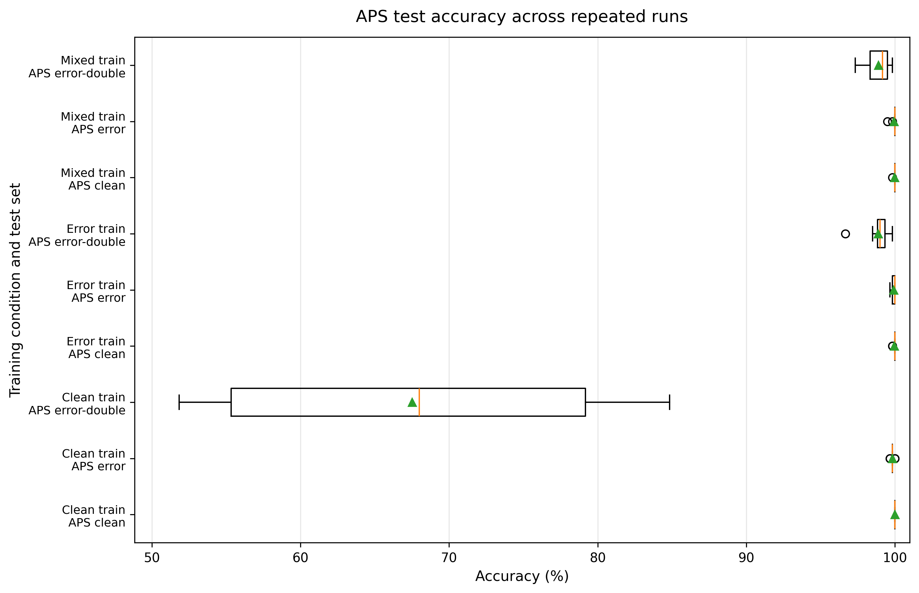
Appendix Figure H1. Distribution of APS test accuracy across repeated runs for each training condition and APS-style test set.

Appendix I. ModelNet40 Primitive-Like Subset Results
ModelNet40 was used as an additional external evaluation through a manually selected primitive-like subset of 486 samples. The full 40-class benchmark was not used because the trained PointNet++ classifier has only three output classes: box, cylinder and sphere. The results should therefore be interpreted only as performance on the selected primitive-like subset.
Appendix Table I1. Single-pass ModelNet40 primitive-like subset results.
Training condition | Runs | Mean accuracy (%) | Median (%) | Best (%)
Clean-trained XYZ-only | 9 | 71.58 | 73.87 | 76.34
Error-trained XYZ-only | 9 | 72.57 | 73.25 | 81.89
Mixed-trained XYZ-only | 9 | 79.81 | 82.10 | 83.54

Mixed training produced the highest single-pass mean accuracy and was therefore selected before the voting evaluation. The Kruskal-Wallis test showed an overall difference between the three conditions (H = 10.0669, p = 0.0065). After Holm correction, mixed training performed significantly better than clean training (U = 6.0, p = 0.0078) and error training (U = 14.0, p = 0.0424), while clean and error training were not significantly different (U = 37.0, p = 0.7908).

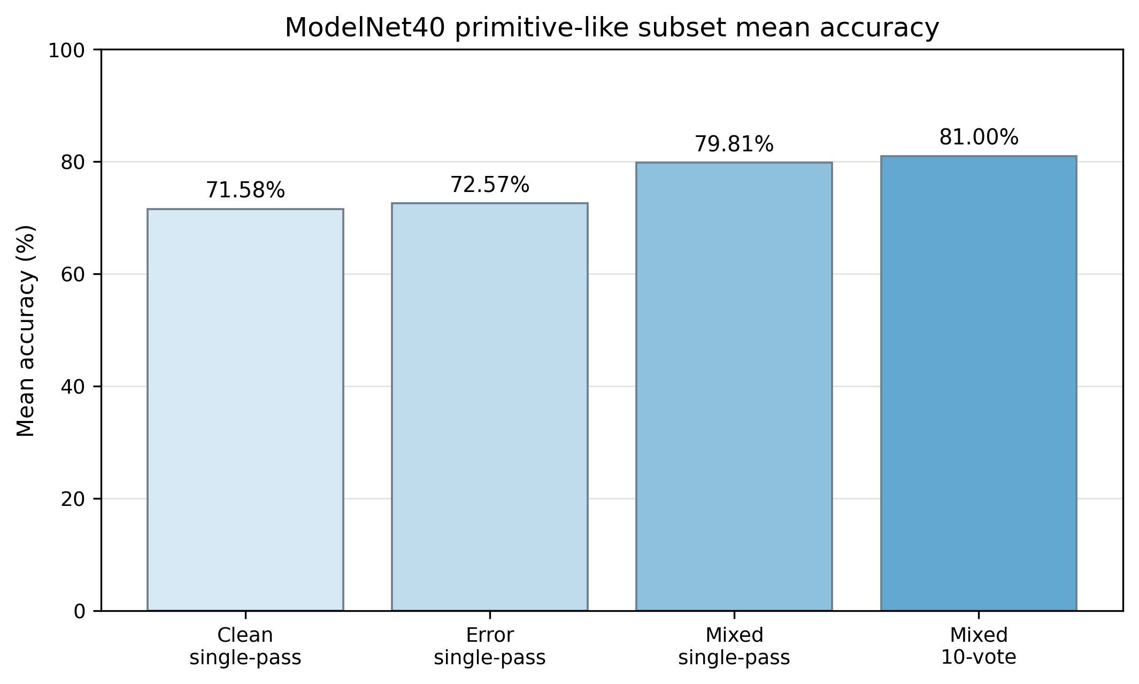
Appendix Figure I1. Mean accuracy on the ModelNet40 primitive-like subset. Ten-vote evaluation was applied only to the mixed model after it had been selected as the best single-pass condition.

Appendix Table I2. Final mixed-model ModelNet40 results using ten-vote test-time evaluation.
Metric | Result
Checkpoints evaluated | 9
Samples | 486
Votes per sample | 10
Mean accuracy | 81.00%
Median accuracy | 82.30%
Standard deviation | 4.37%
Best accuracy | 84.98%

Ten-vote evaluation increased the mixed-model mean accuracy from 79.81% to 81.00% and the best accuracy from 83.54% to 84.98%. The voting method did not retrain the network. Each object was sampled ten times using different 1000-point subsets, the predicted class probabilities were averaged, and the final class was selected from the averaged probabilities.
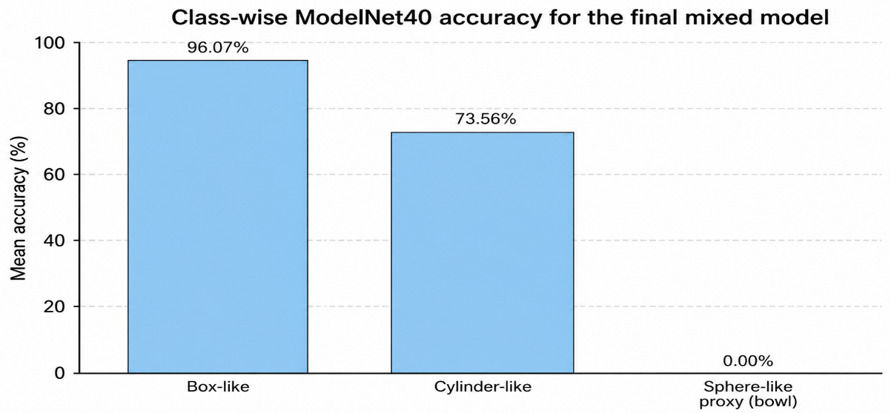
Appendix Figure I2. Class-wise ModelNet40 accuracy for the final mixed-trained XYZ-only model. Bowl is retained only as a weak sphere-like proxy.
Appendix Table I3. Class-wise ModelNet40 results for the final mixed model.
Mapped primitive | Mean accuracy (%) | Interpretation
Box-like | 96.07 | Strongest mapped class
Cylinder-like | 73.56 | Moderate transfer
Sphere-like proxy (bowl) | 0.00 | Weak proxy; not a true sphere

ModelNet40 does not contain a true sphere, ball or similar closed spherical category. Bowl was therefore used only as a weak sphere-like proxy. Across 180 bowl predictions, 171 were classified as cylinder and none were classified as sphere. This should mainly be treated as a limitation of the manual class mapping rather than as evidence of poor performance on true spherical objects. YCB-28 provides the more suitable evaluation of the sphere class.

Appendix J. Extended RProp optimiser results
RProp was a supplementary optimiser comparison requested after the main AdamW experiments. The results below use the final RProp result set: 10 independent runs, 71.20% mean YCB-28 accuracy, 71.61% median accuracy and 72.86% best accuracy.

Appendix Table J1. RProp YCB-28 results across ten independent runs.
Run | Accuracy (%) | Mean confidence
1 | 68.75 | 0.7793
2 | 71.61 | 0.7836
3 | 69.11 | 0.7799
4 | 71.61 | 0.8019
5 | 70.36 | 0.8243
6 | 71.43 | 0.8010
7 | 72.86 | 0.8065
8 | 72.14 | 0.7811
9 | 71.96 | 0.7732
10 | 72.14 | 0.7821

Appendix Table J2. Five-number summary and descriptive statistics for RProp YCB-28 accuracy.
Minimum (%) | Q1 (%) | Median (%) | Q3 (%) | Maximum (%) | Mean (%) | SD (%)
68.75 | 70.63 | 71.61 | 72.10 | 72.86 | 71.20 | 1.35

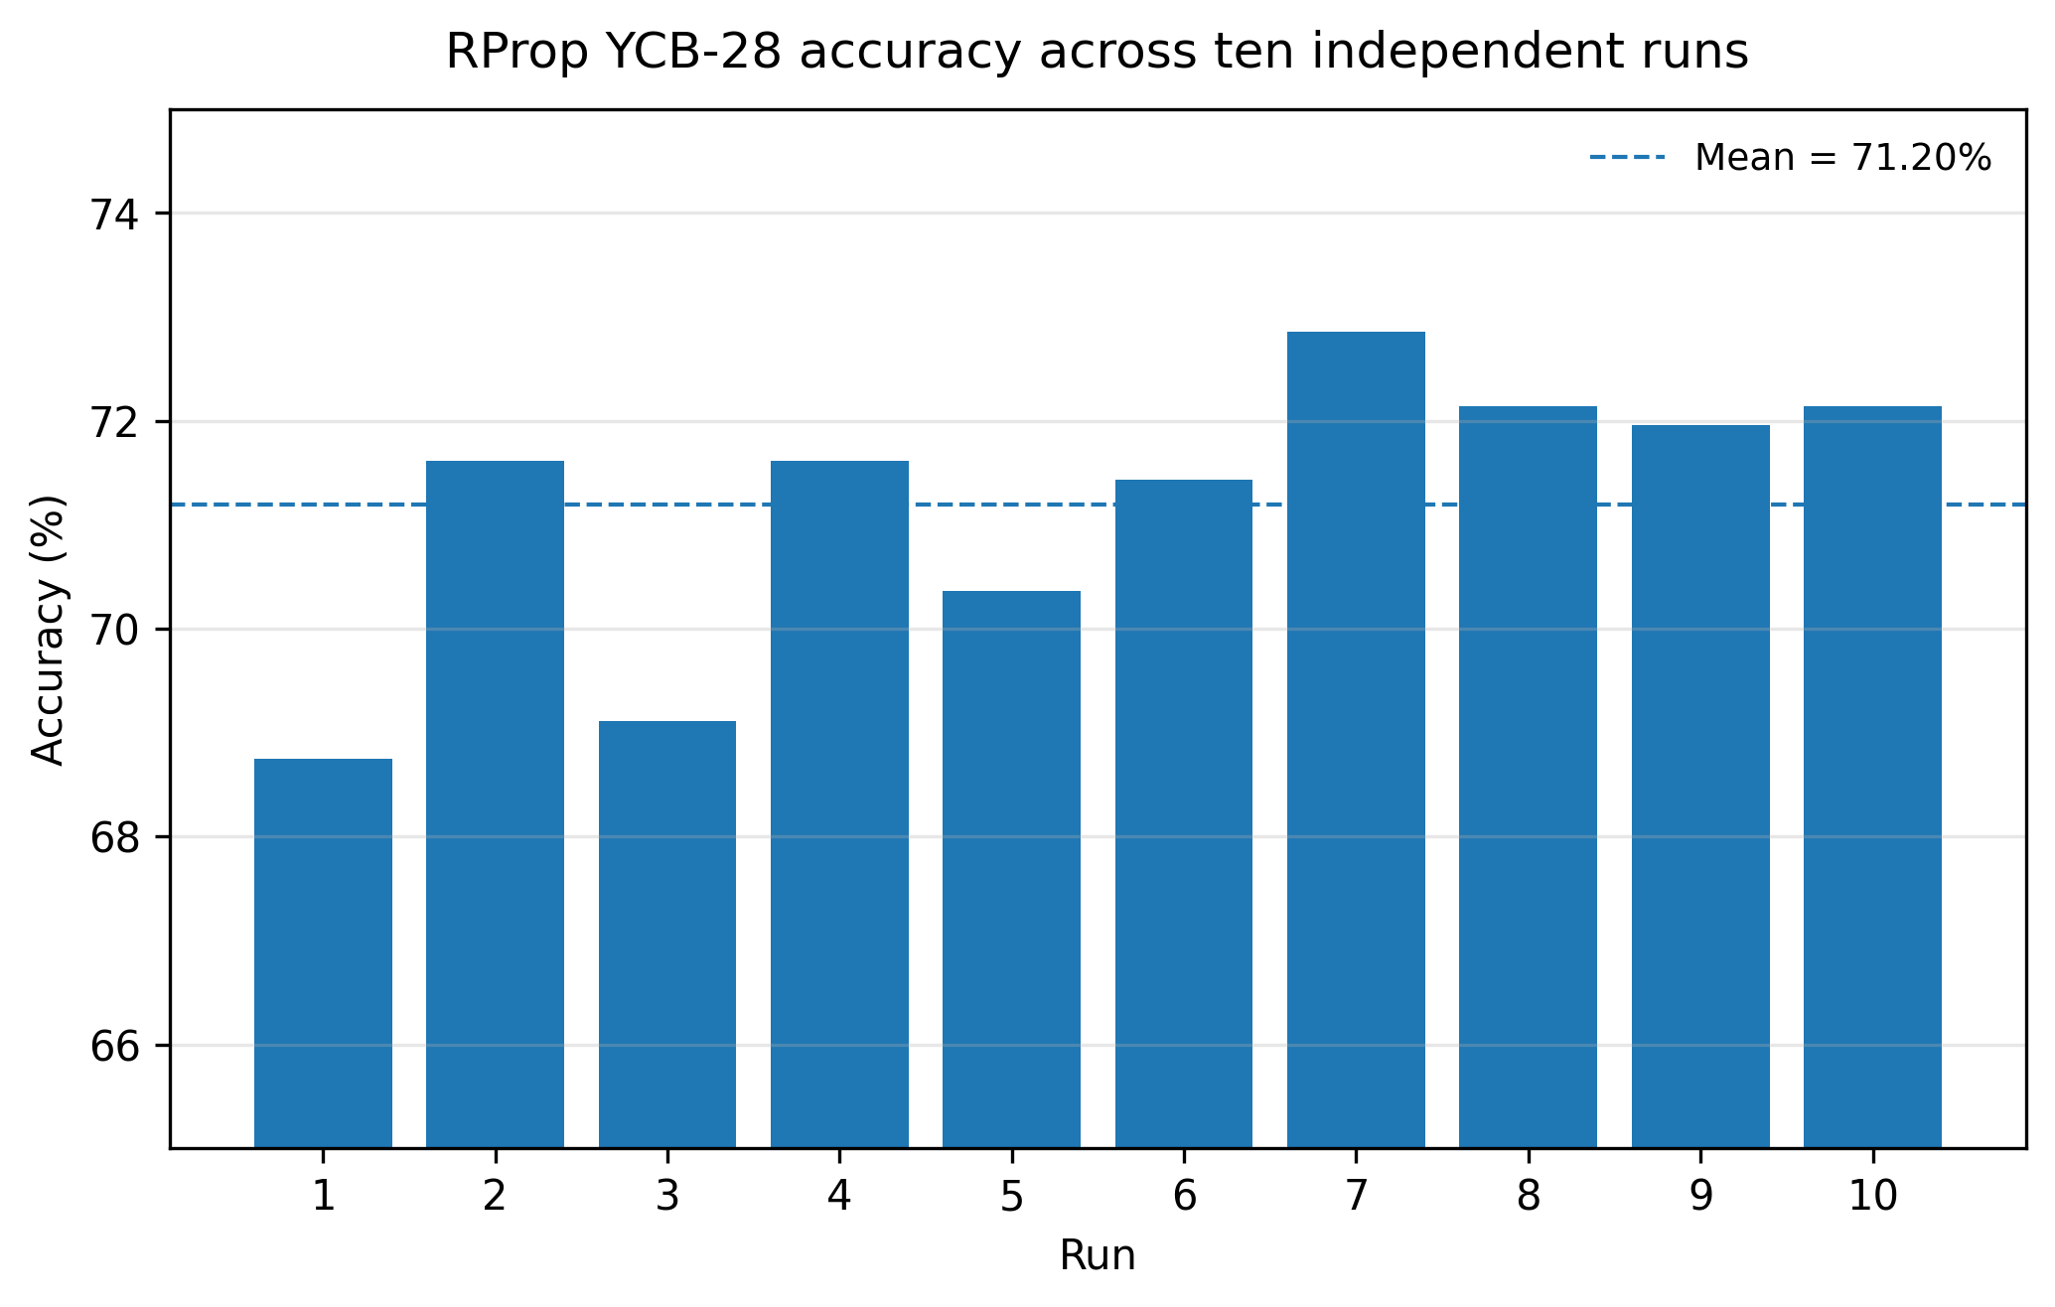
Appendix Figure J1. RProp YCB-28 accuracy across ten independent runs. The dashed line indicates the mean accuracy.
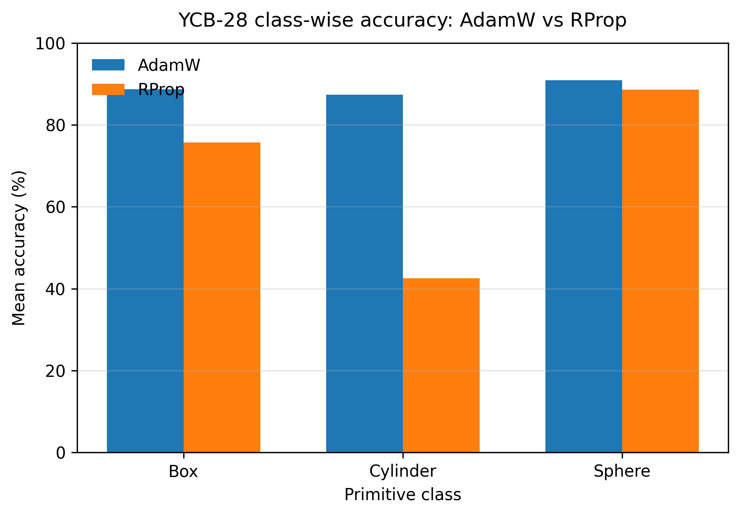
Appendix Figure J2. Class-wise YCB-28 comparison between the final mixed AdamW model and the supplementary RProp model.

Appendix K. Supplementary Real-Object and Point-Cloud Visualisations
This appendix provides qualitative comparisons between the real YCB-28 objects and the corresponding sampled XYZ point clouds presented to the final PointNet++ classifier. In each comparison, the real object is shown alongside its normalised point-cloud representation, with the true primitive class, predicted class, object-level accuracy and confidence reported in the visual annotation. These figures complement the quantitative YCB-28 results by showing how real object geometry is represented after sampling and preprocessing.
The YCB-28 object identities follow the primitive mapping used in this project [9,13]. The point-cloud plots and prediction annotations were generated during the final mixed-trained XYZ-only AdamW evaluation. Representative comparisons are shown below.

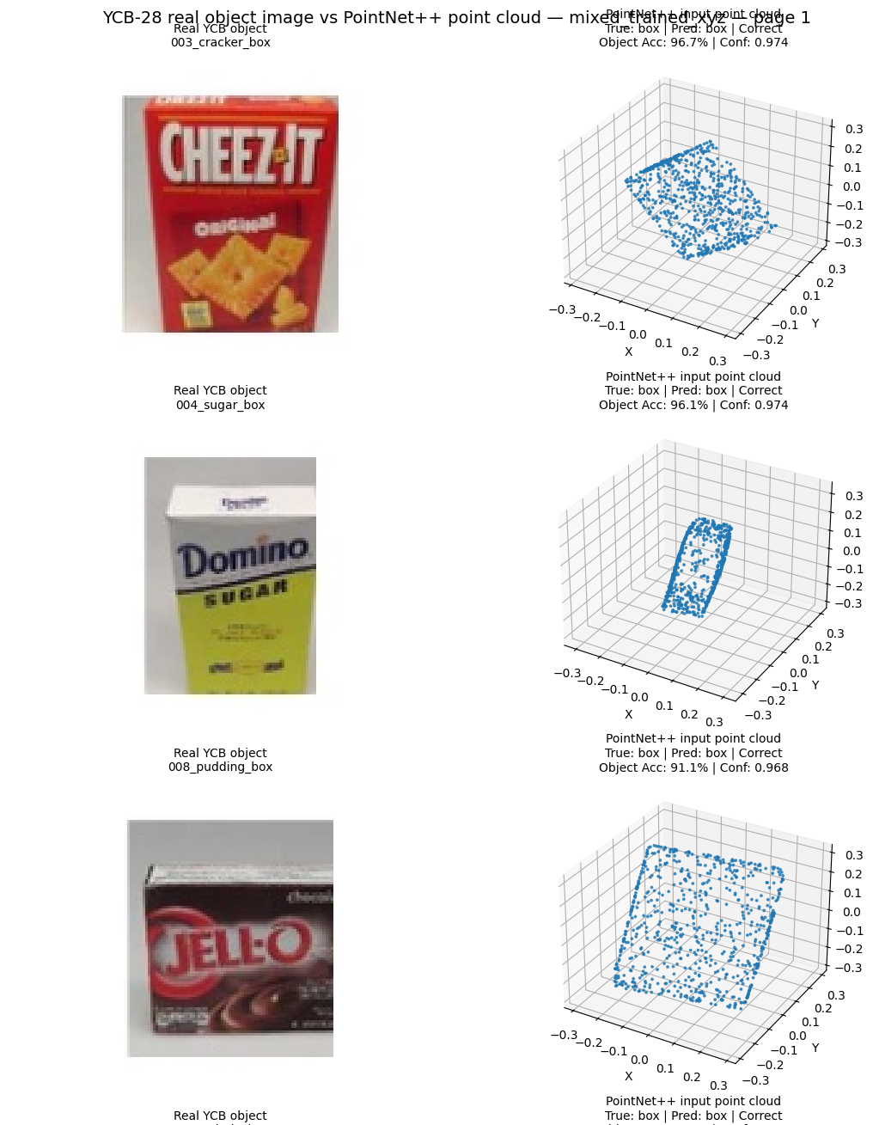
Appendix Figure K1. YCB-28 real-object and PointNet++ input point-cloud comparisons for box-like objects: sugar box and pudding box.
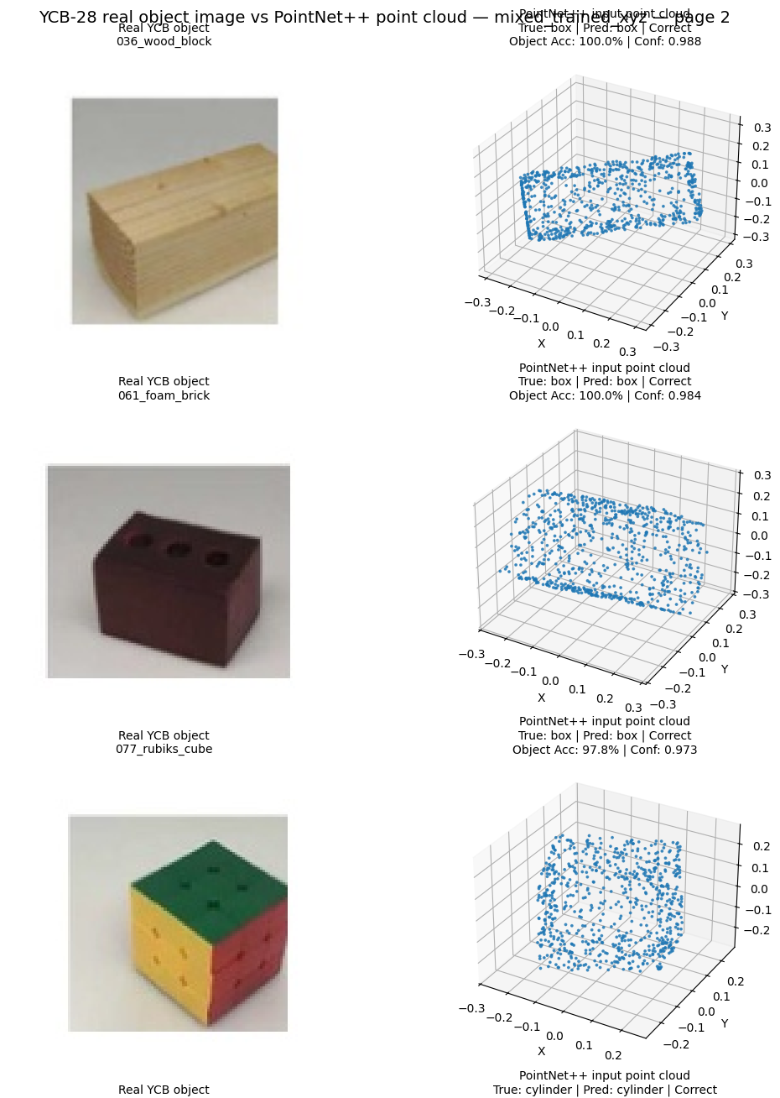
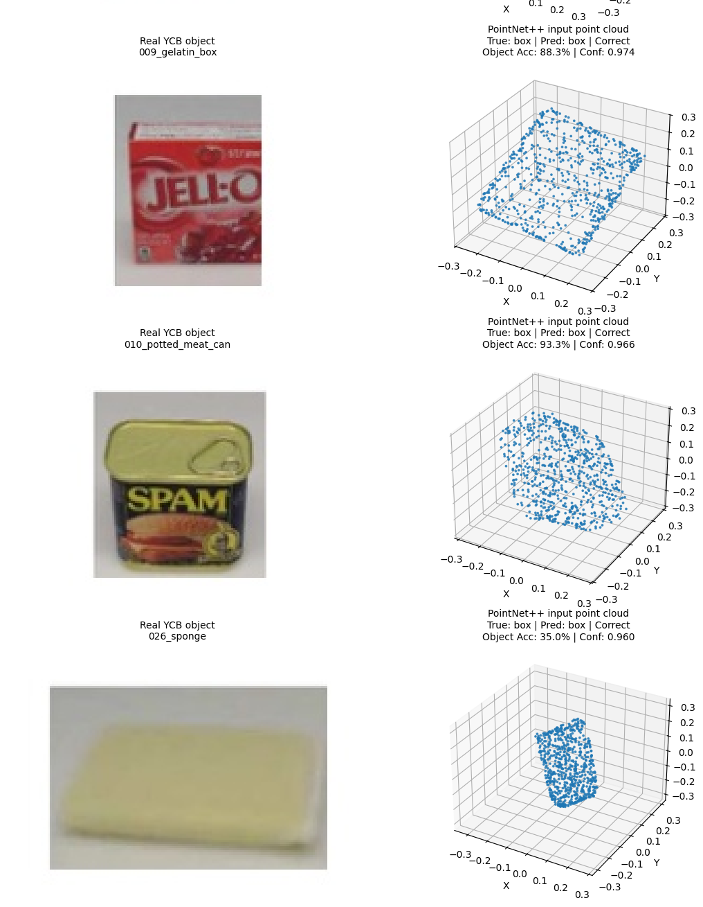

Appendix Figure K2. YCB-28 real-object and PointNet++ input point-cloud comparisons for additional box-like objects: foam brick, rubik's cube, potted meat can and sponge.
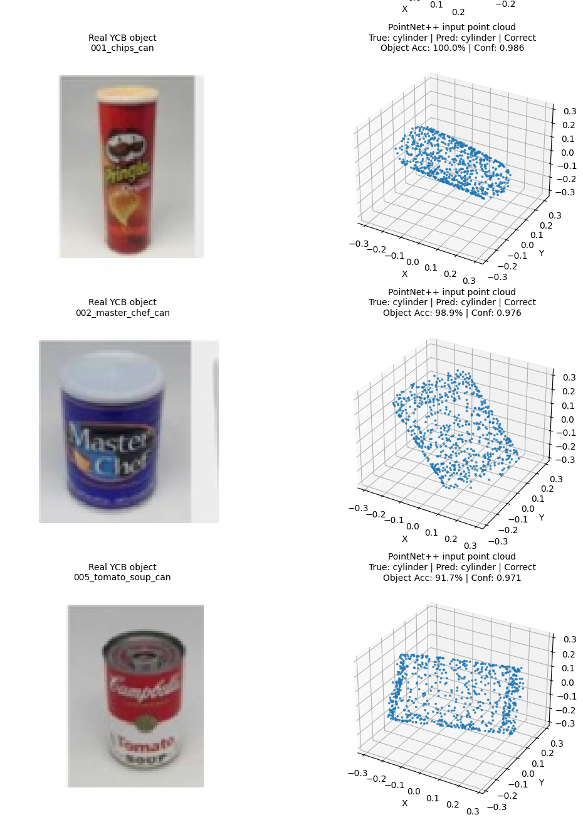
Appendix Figure K3. YCB-28 real-object and PointNet++ input point-cloud comparisons for cylinder-like objects: chips can, master chef can and tomato soup can.
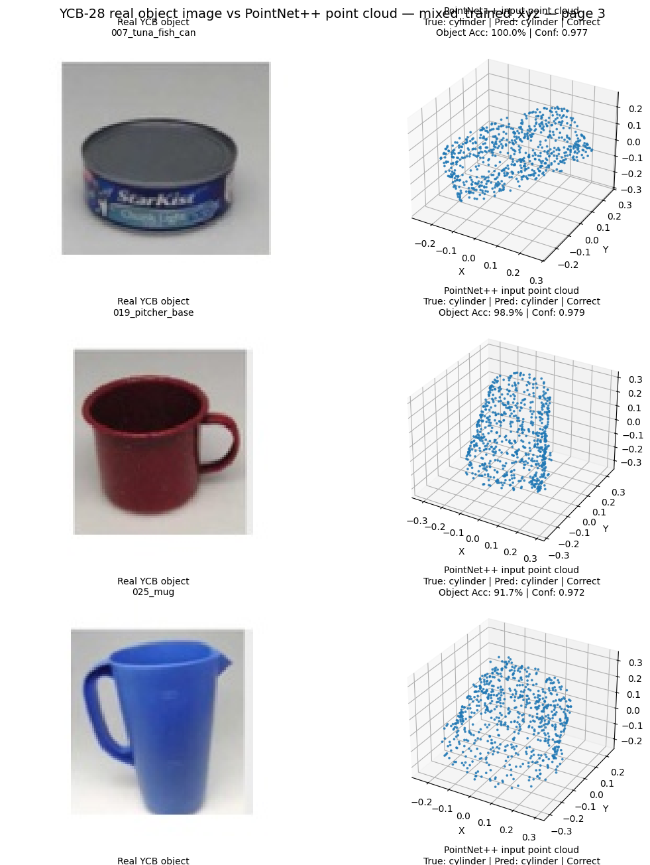
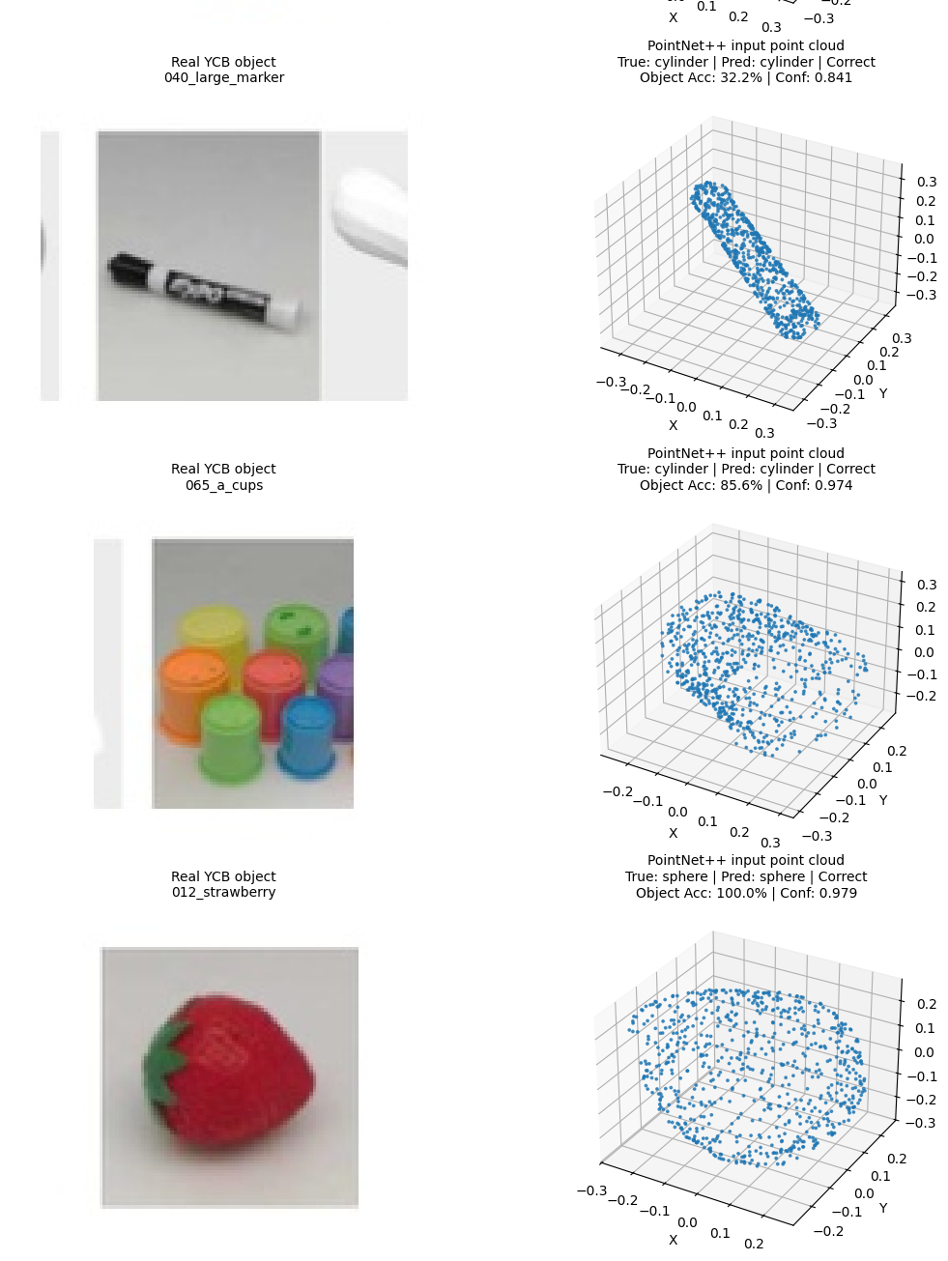
Appendix Figure K4. YCB-28 real-object and PointNet++ input point-cloud comparisons for cylinder-like objects: pitcher base, mug, large marker and cups.
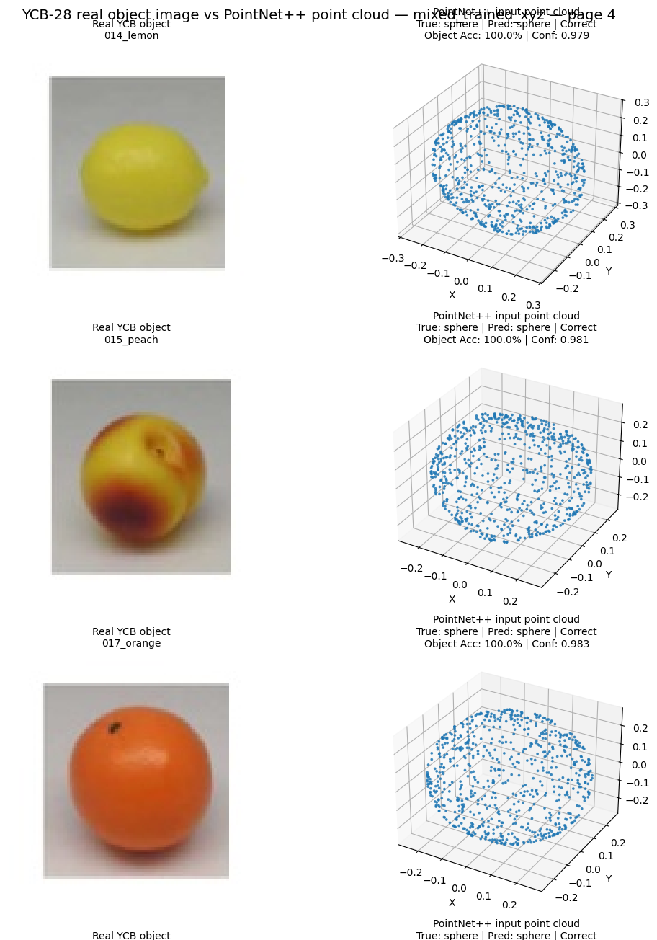

Appendix Figure K5. YCB-28 real-object and PointNet++ input point-cloud comparisons for sphere-like objects: lemon, peach, orange and strawberry.
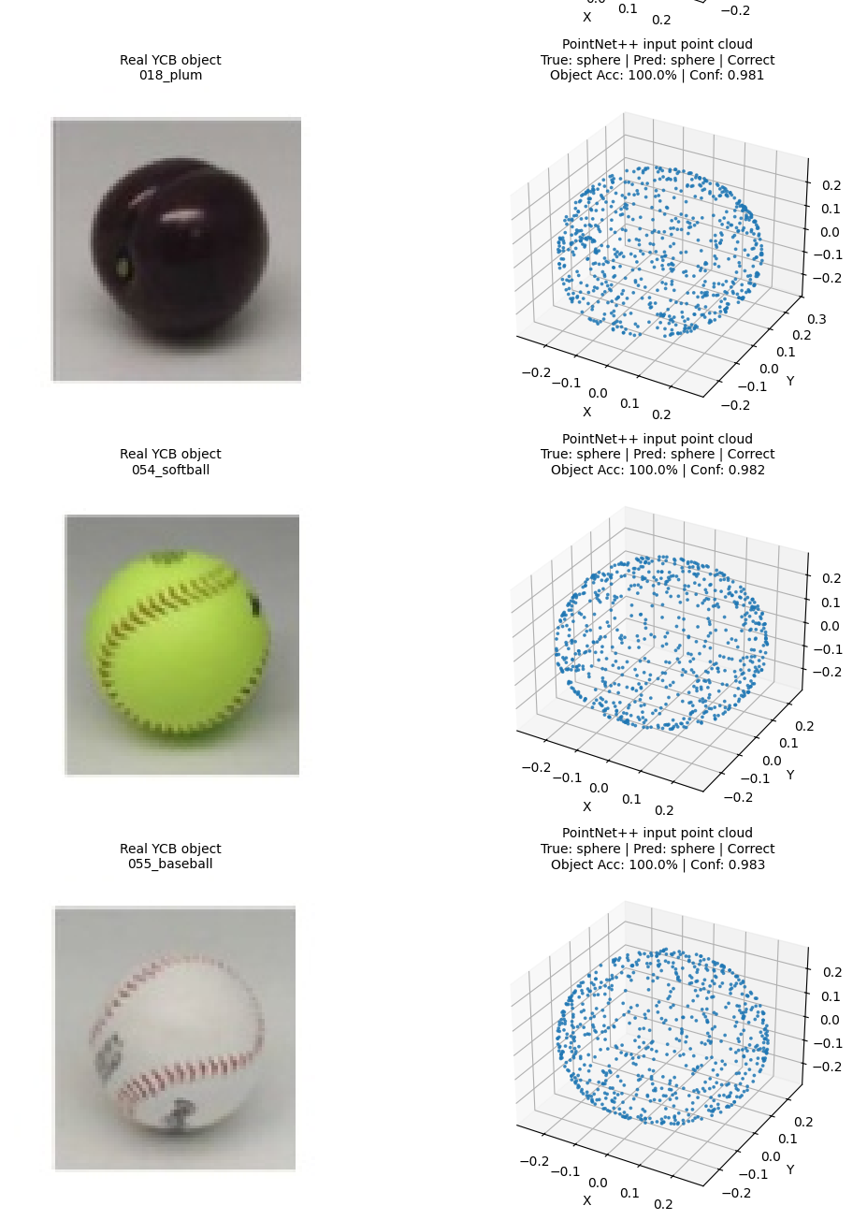
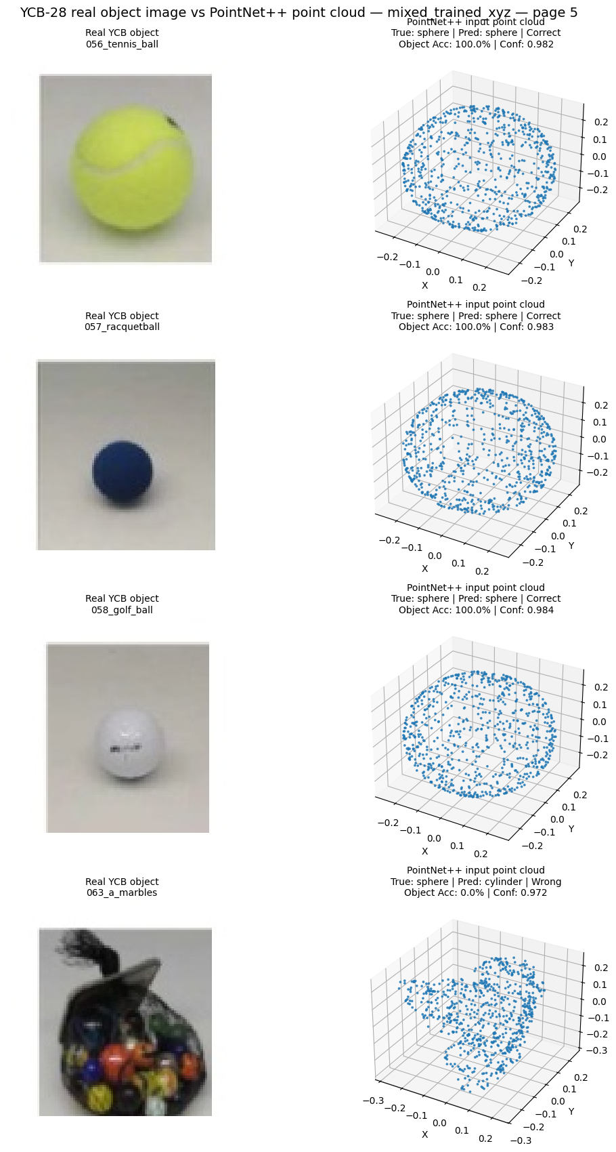
Appendix Figure K6. YCB-28 real-object and PointNet++ input point-cloud comparisons for sphere-like objects: plum, softball and the marbles failure case

Qualitative interpretation. The paired visualisations show that many YCB objects retain a dominant geometric structure that corresponds reasonably well to the synthetic box, cylinder or sphere classes after point sampling and normalisation. The comparison also highlights the limitations of the three-class abstraction. The large marker is substantially thinner and more elongated than the APS cylinders, the sponge has an irregular rounded cuboid form, and the marbles object is a compound collection rather than a single sphere. These geometric differences are consistent with the lower object-level accuracies reported for these cases in Appendix D.
Source note: the real-object photographs correspond to objects from the YCB object and model set [13] and the YCB-28 mapping used in the reference primitive-recognition study [9]. The sampled point-cloud visualisations, predictions, accuracies and confidence annotations were generated as part of this project's YCB-28 evaluation.

https://github.com/khosekunal98-droid/pointnetpp-primitive-shape-generalisation

